**Collection Framework**



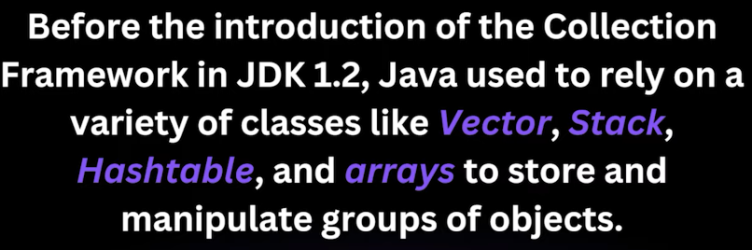

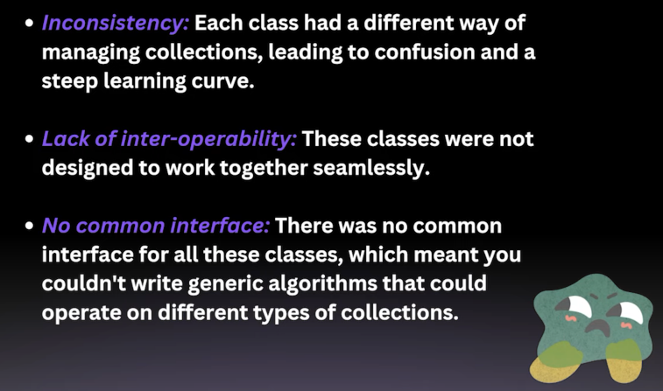

Using Collections –

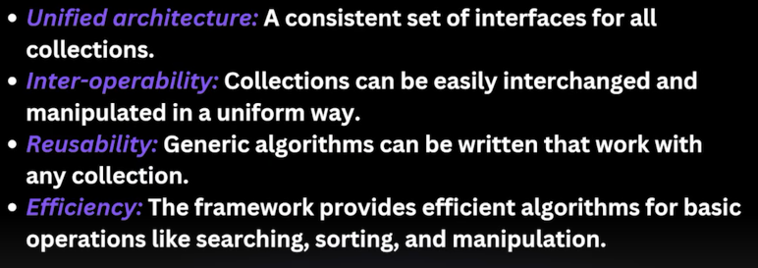

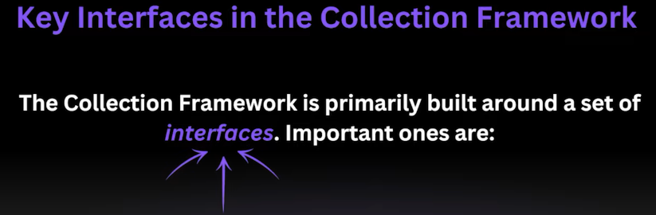

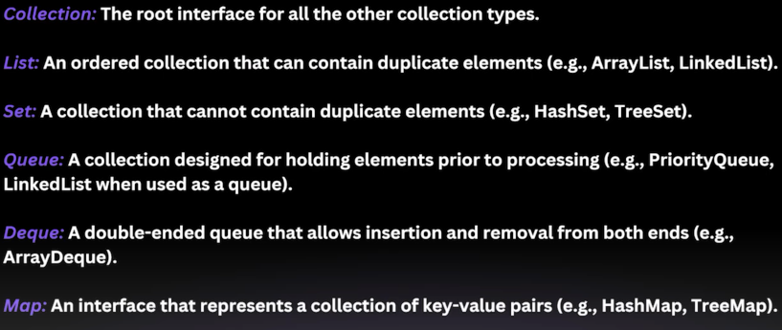

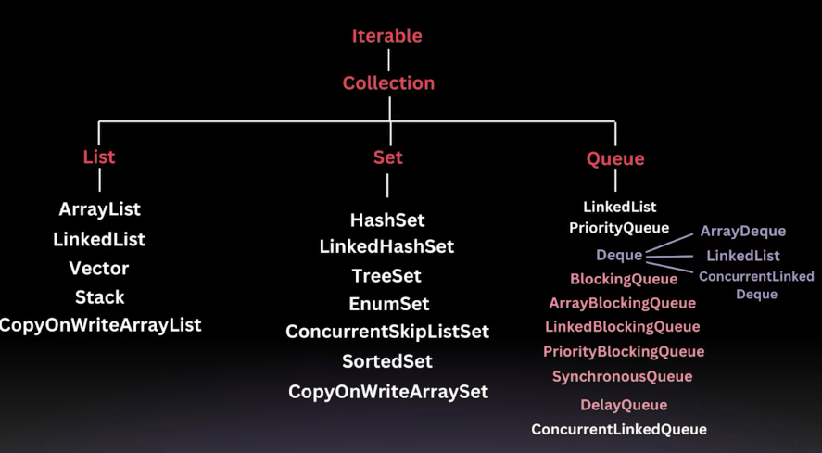

For-each loop syntax works on arrays and anything that implements Iterable.

forEach() method works on Iterable (e.g., ArrayList, Set, etc.) and **Streams**.

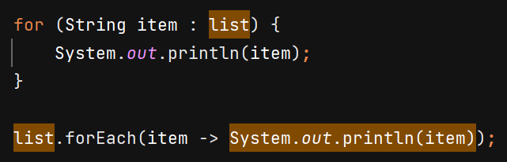

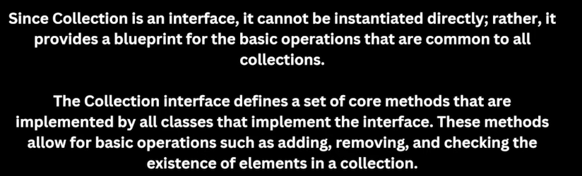

**List Interface**

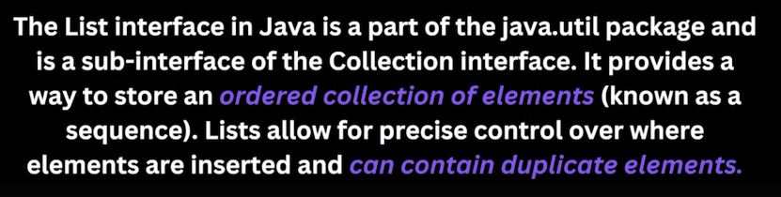



**ArrayList**

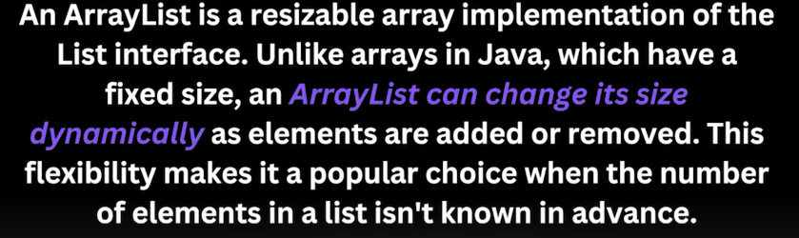

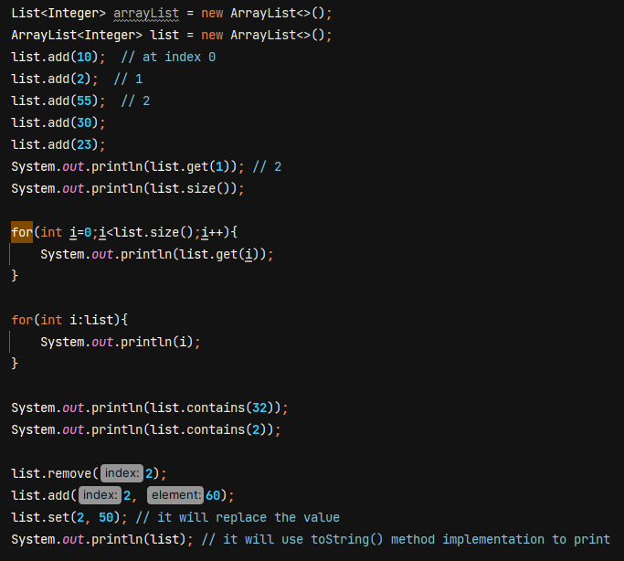

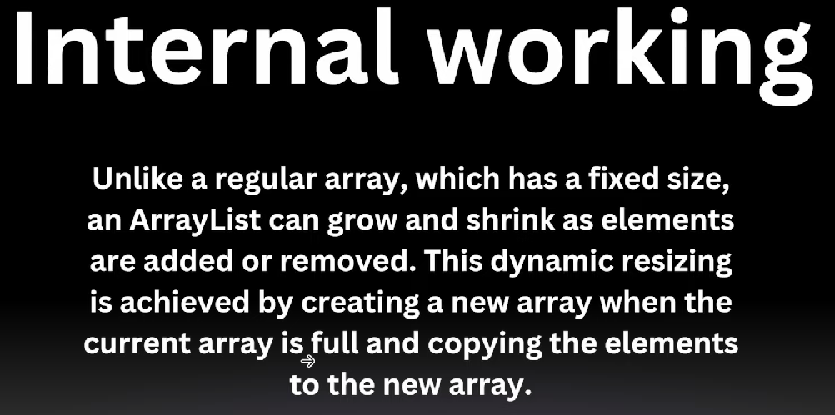

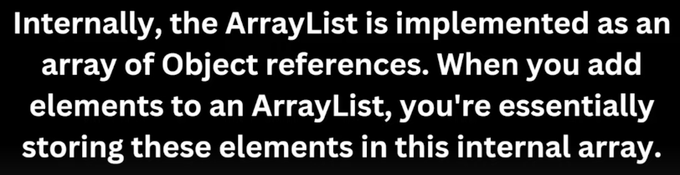

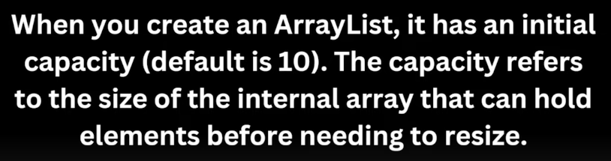

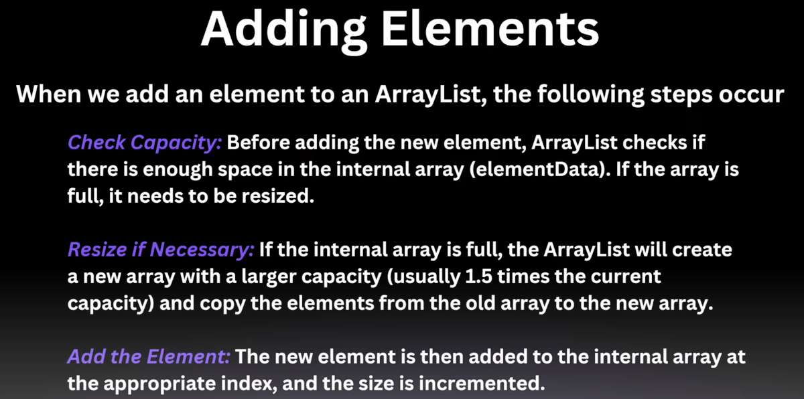

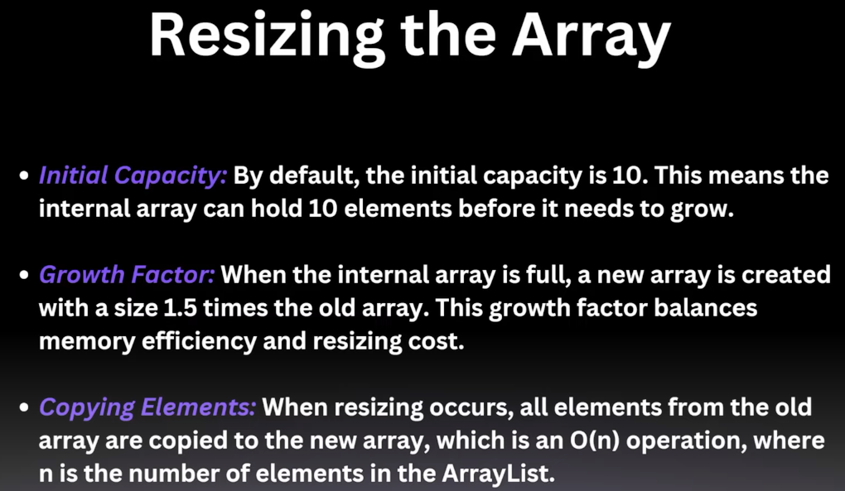

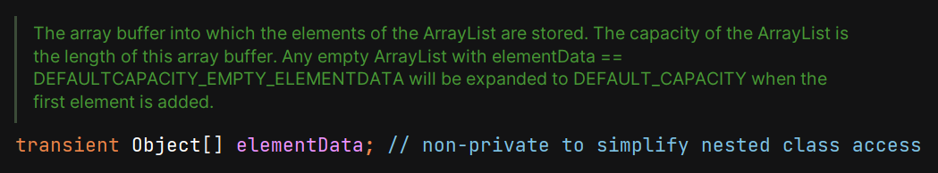

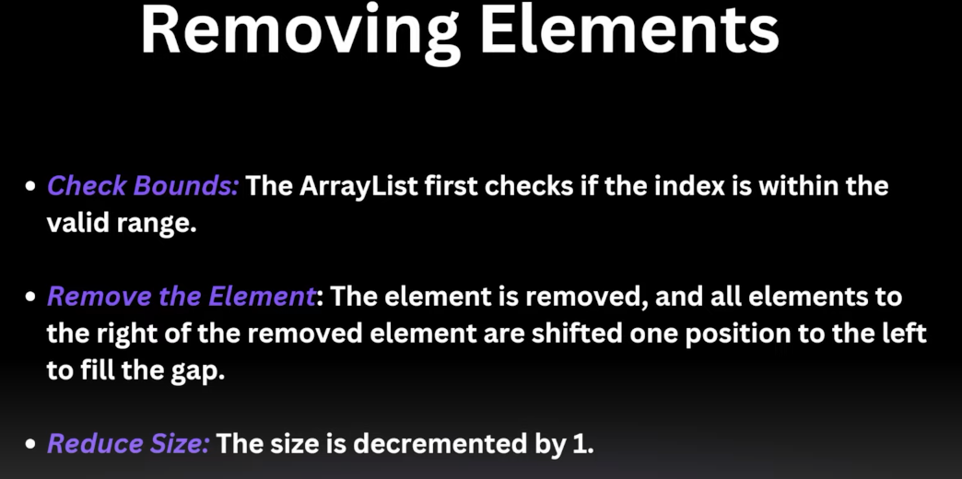

**Note :-**

To prevent the overhead of copying elements, if u know that ArrayList will have alteast n no of element then we can give initial capacity at initialisation.

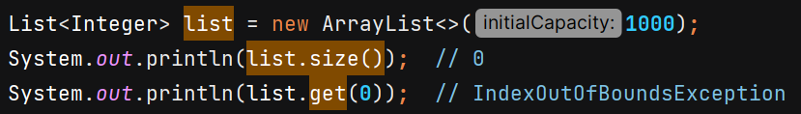

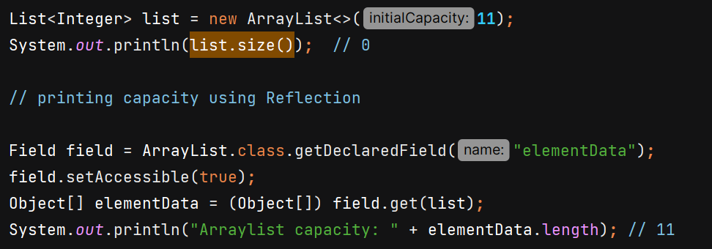

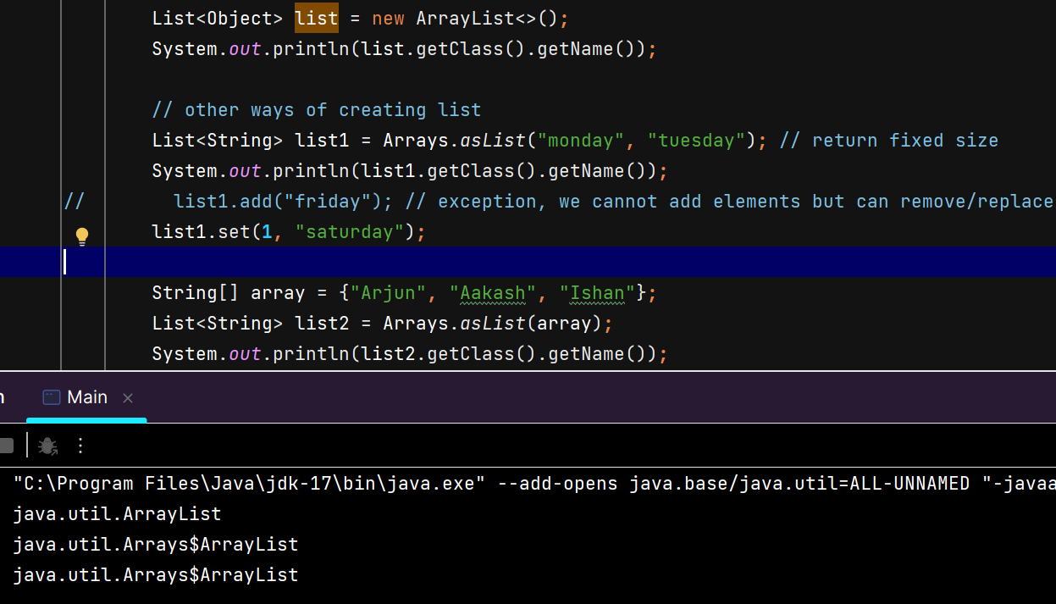

In ArrayList constructor we can give capacity or Collection.

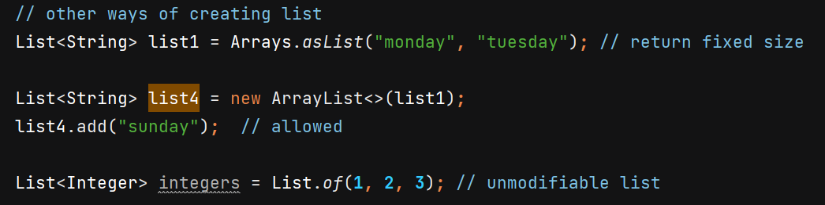

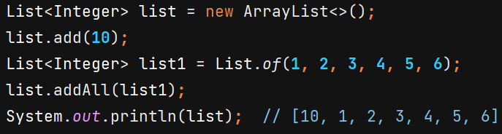

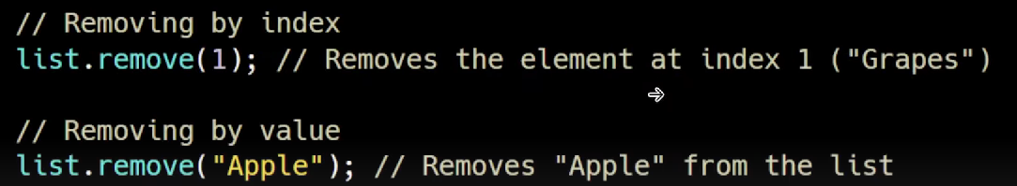

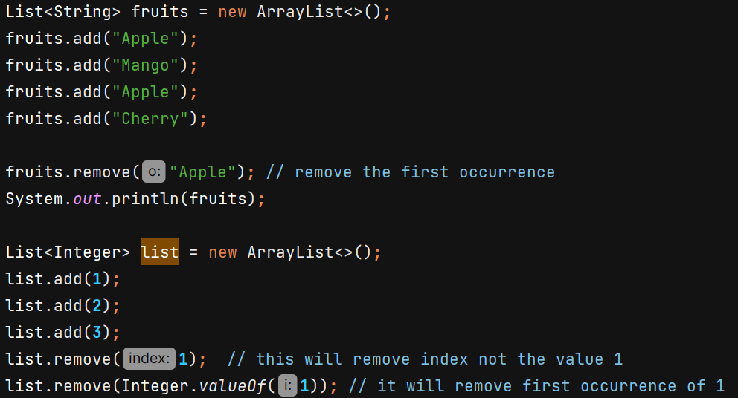



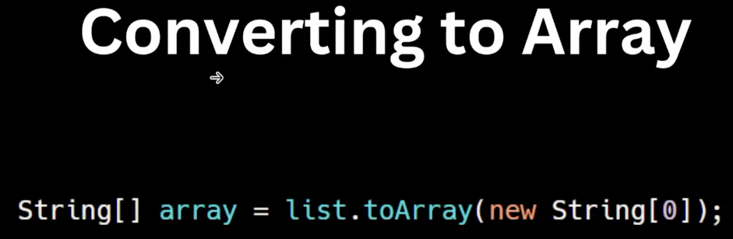

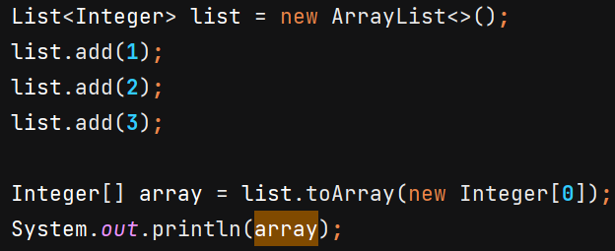

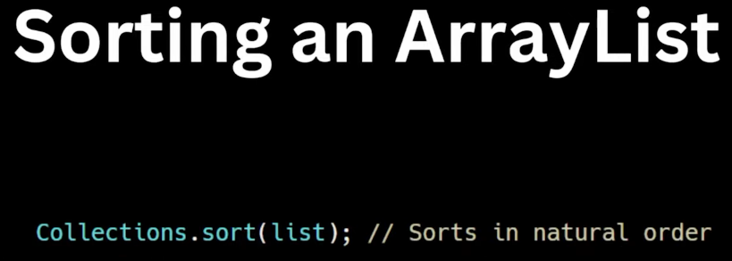

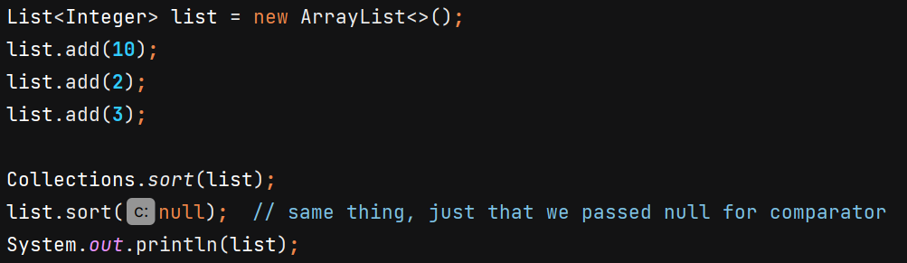

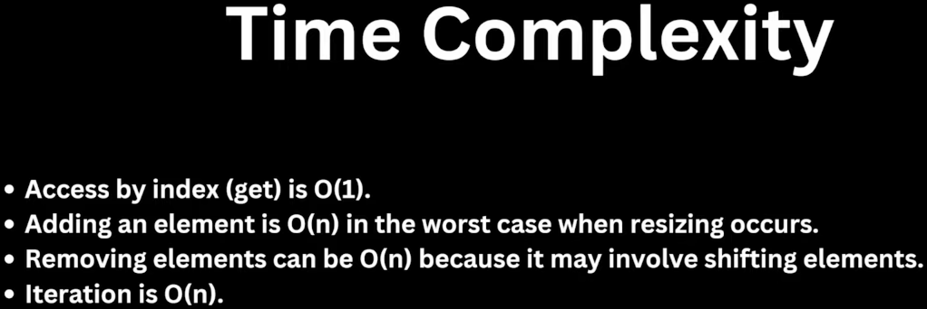

**Comparator** 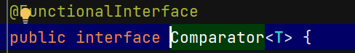

Its an interface using which we can do custom sorting.

It has which compares two objects of same type and determine their order.

The integer returned tells the relative order of two objects.

* If -ve then o1 comes first then o2
* 0 then o1 & o2 equal in ordering
* +ve then o2 comes first then o1

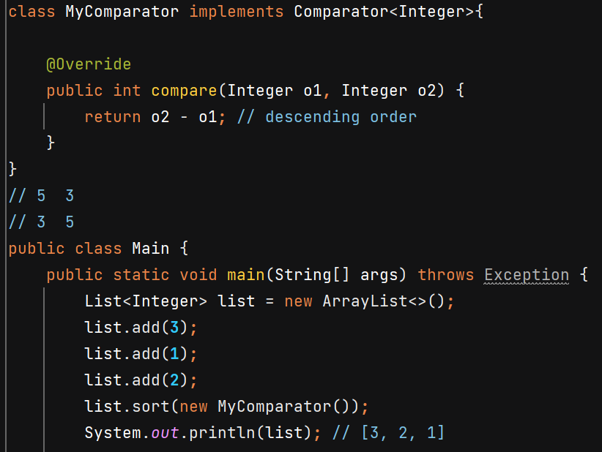

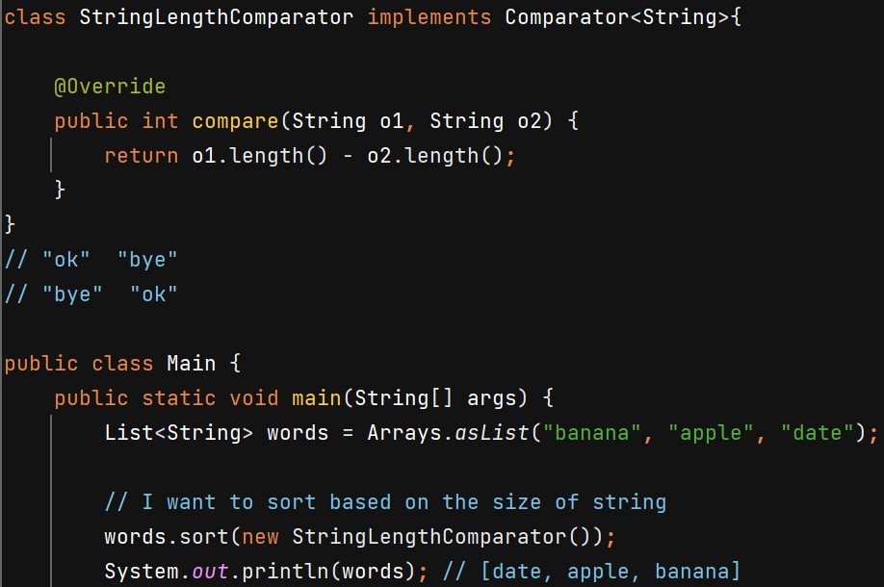

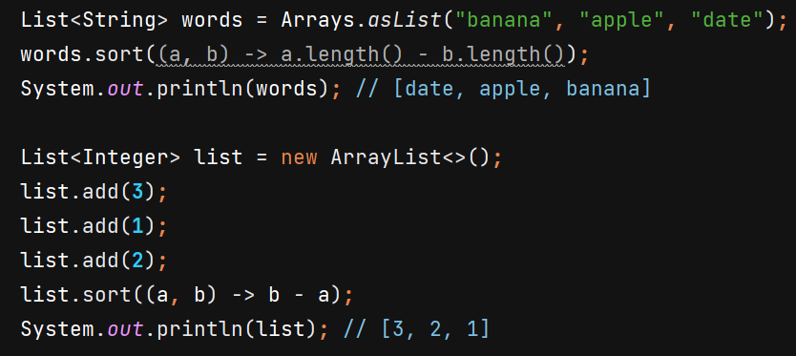

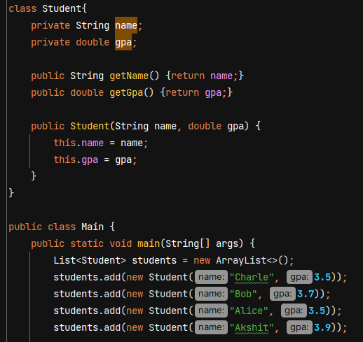

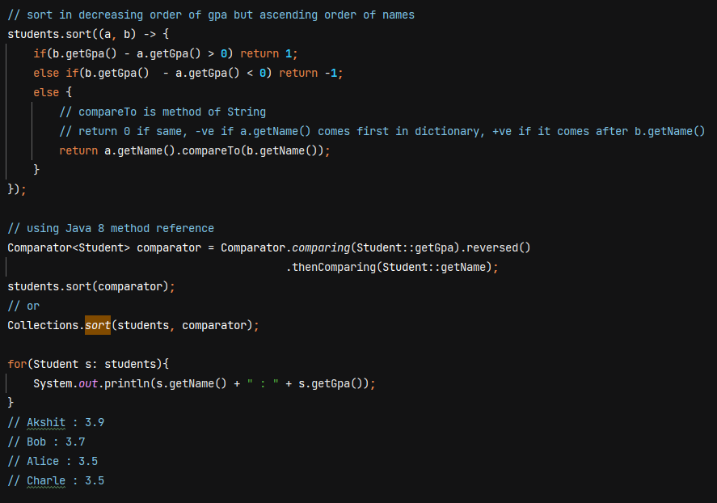

**LinkedList**

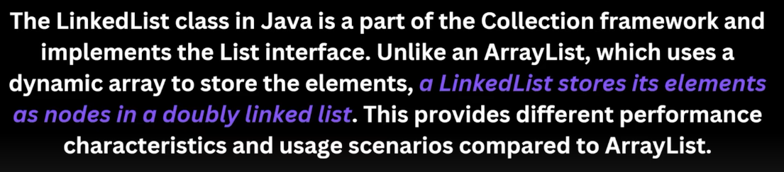

Custom implementation will be like –

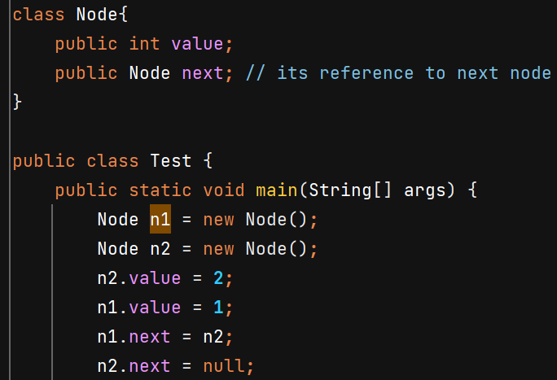



But Java internally provides –

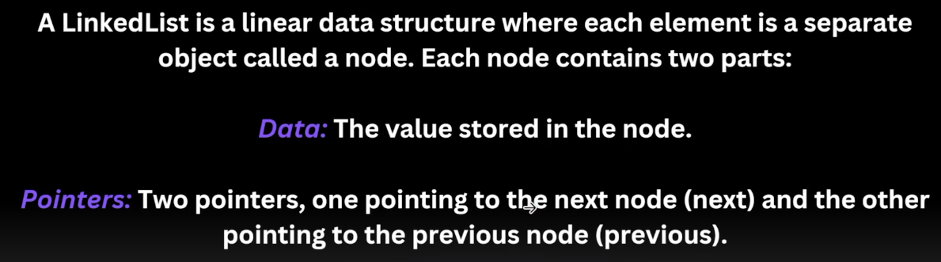

We can’t directly access the elements with .get(i) in O(1) instead we have to run loop so time complexity of get(i) is O(n)

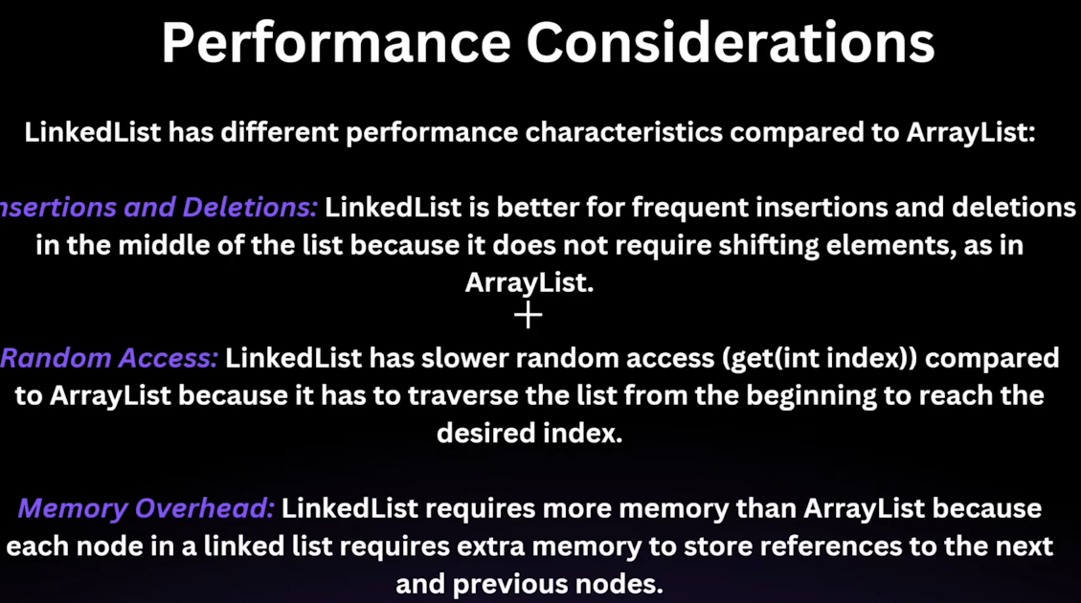

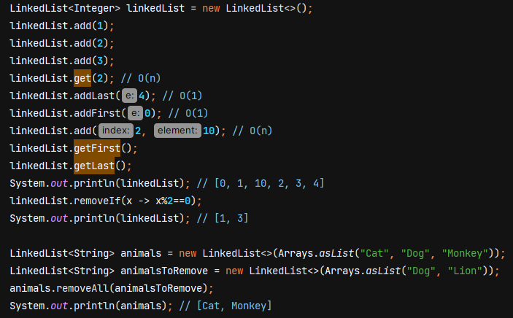

We can also write reference as List, but then we won’t be able to access the method which aren’t part of List interface.

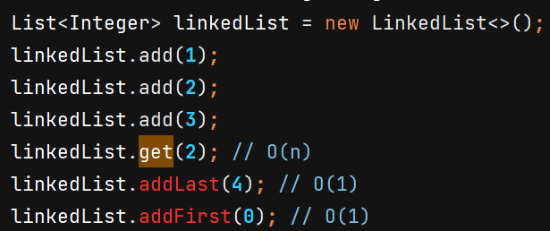

**Vector**

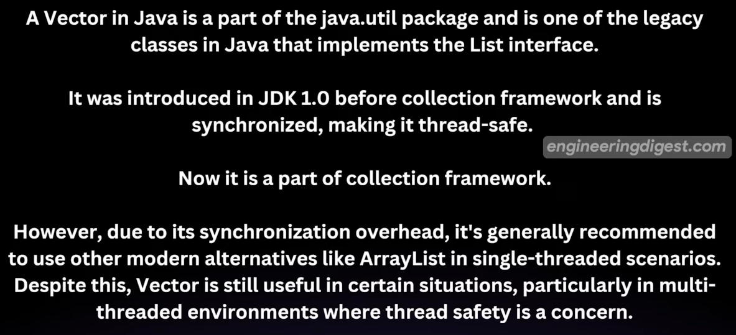

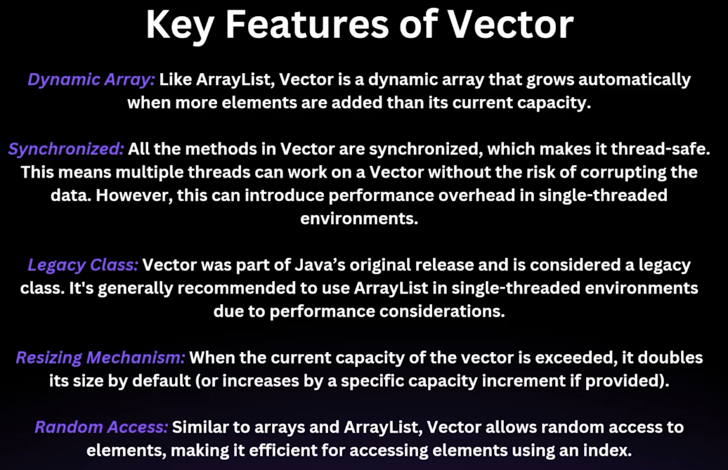

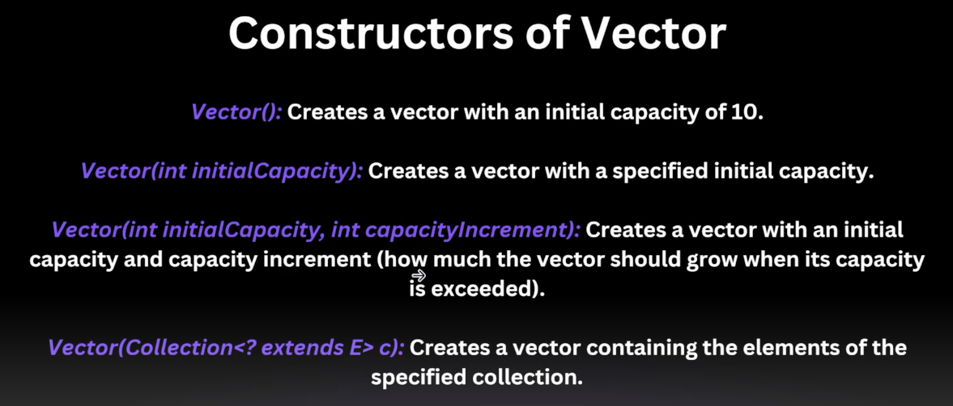

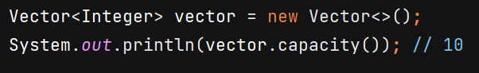

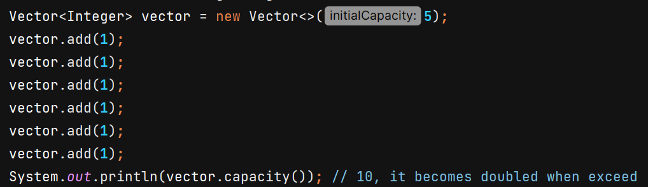

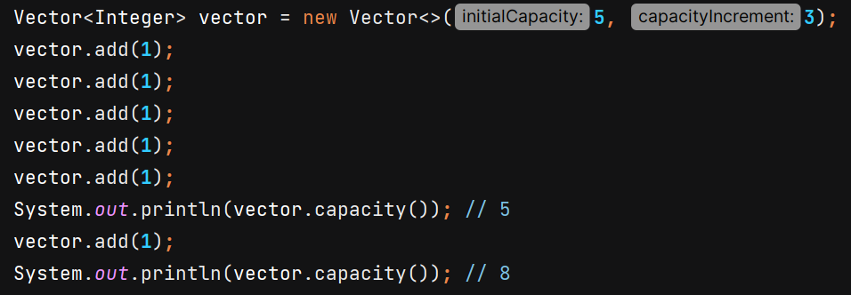

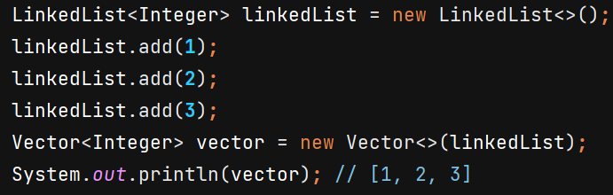

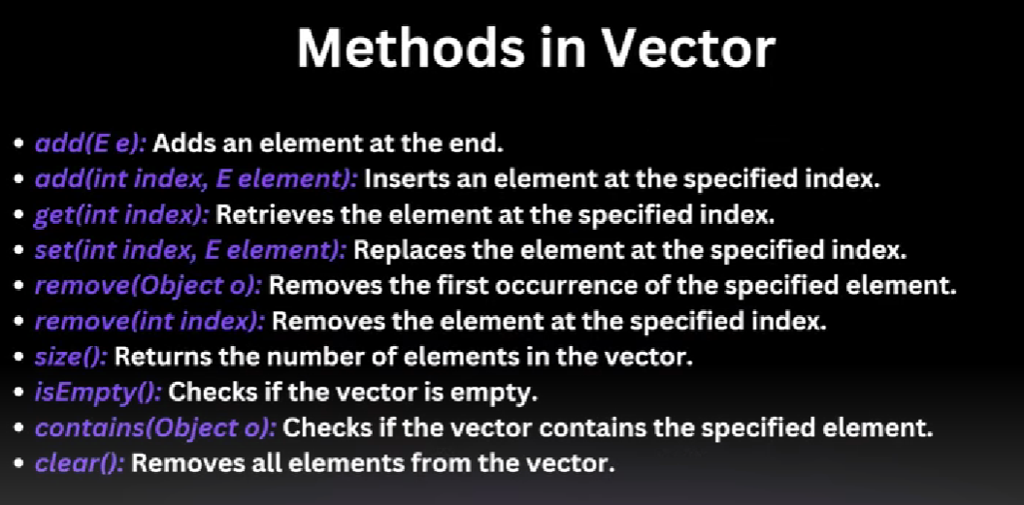

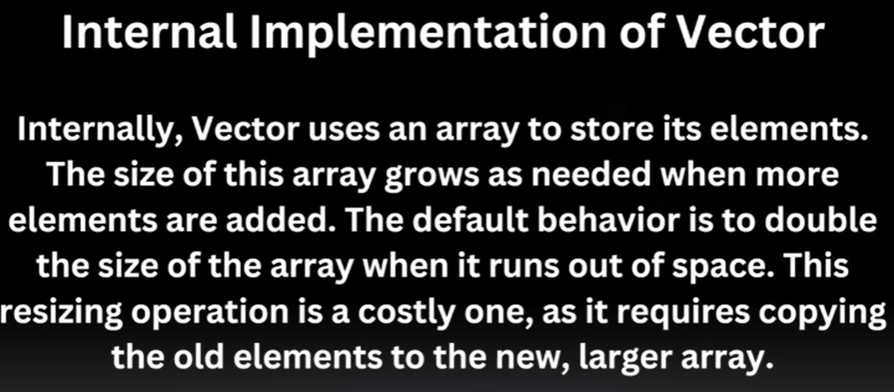

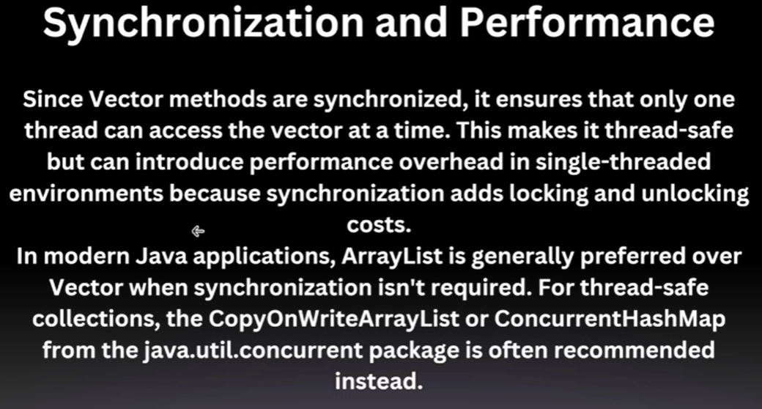

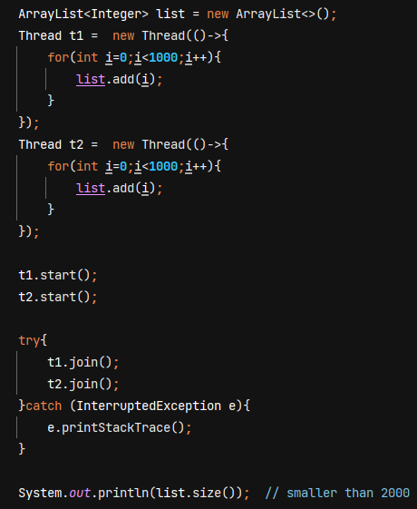

Threadsafe – at same instant only 1 thread can access the list and add

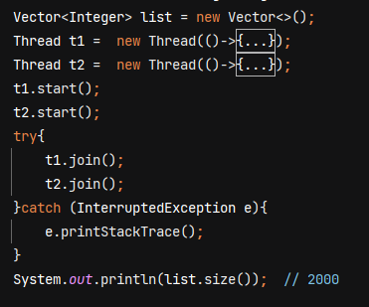

**Stack**



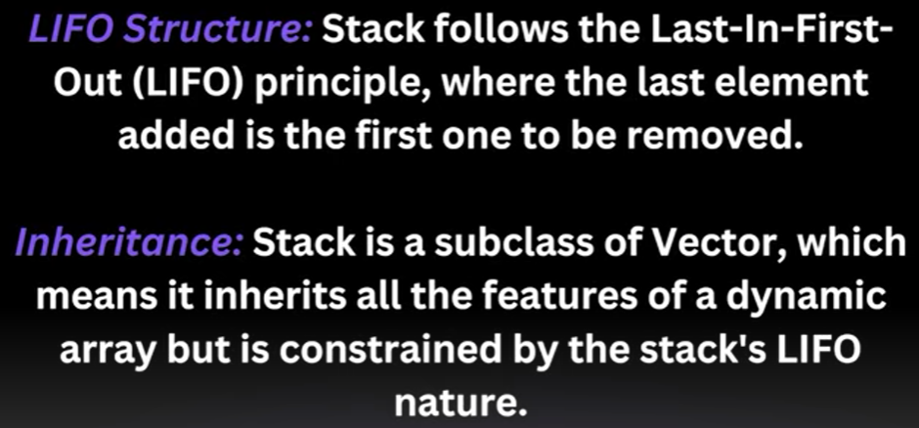

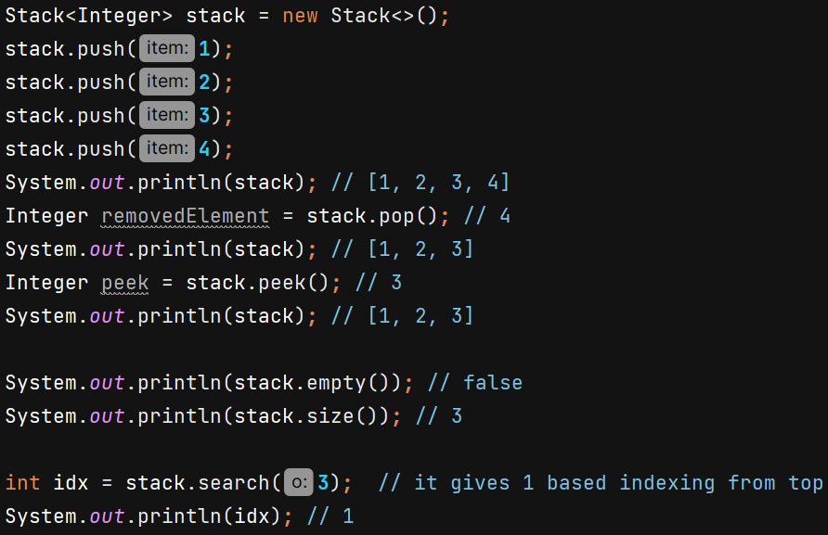

**LinkedList as stack** : -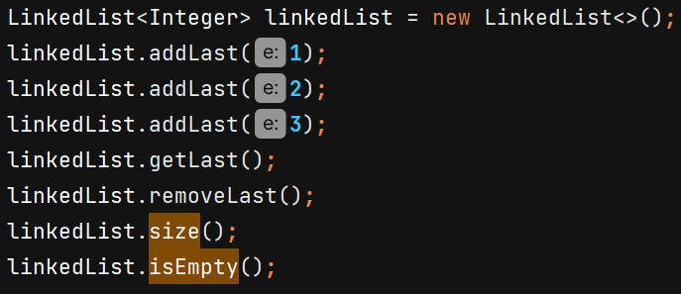

In single threaded environment we can use LinkedList as stack to avoid synchronization overheads.

**ArrayList as stack** :- 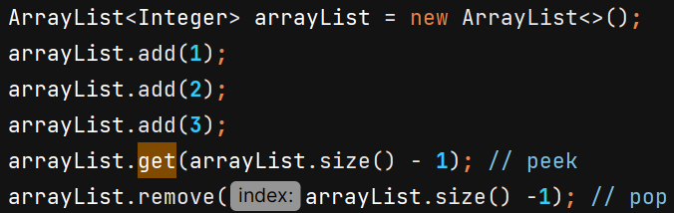

**CopyOnWriteArrayList**

"Copy on Write" means that whenever a write operation like adding or removing an element then instead of directly modifying the existing list, a new copy of the list is created, and the modification is applied to that copy. This ensures that other threads reading the list while it’s being modified are unaffected.

Read Operations: Fast and direct, since they happen on a stable list without interference from modifications.

Write Operations: A new copy of the list is created for every modification. The reference to the list is then updated so that subsequent reads use this new list.

This is preferred when reads are more and write are less becoz creating new copy of list needs memory consumption.

ArrayList should not get modified while reading -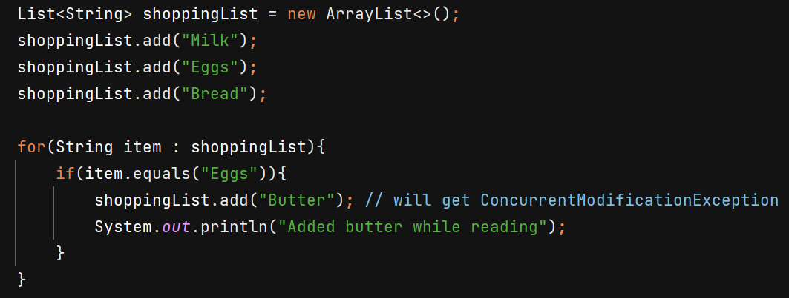

Works fine now -

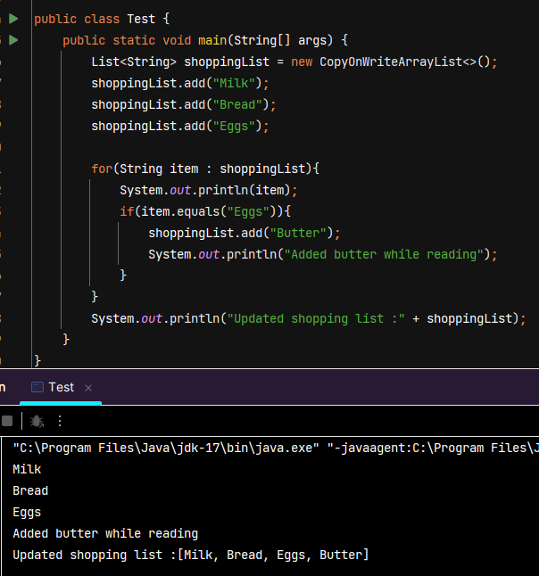

Reading and modifying happening at same time. Its possible because read happened on original snapshot but write happened on separate copy. Loop will only run on original list. When read is complete then shoppingList reference variable will start pointing to new copy list.

Another example to demonstrate –

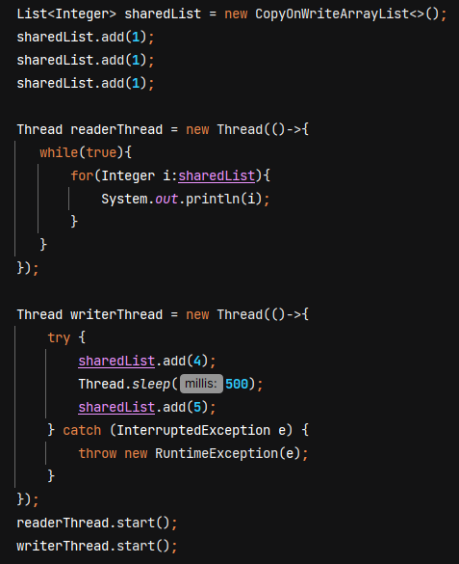

**Map**

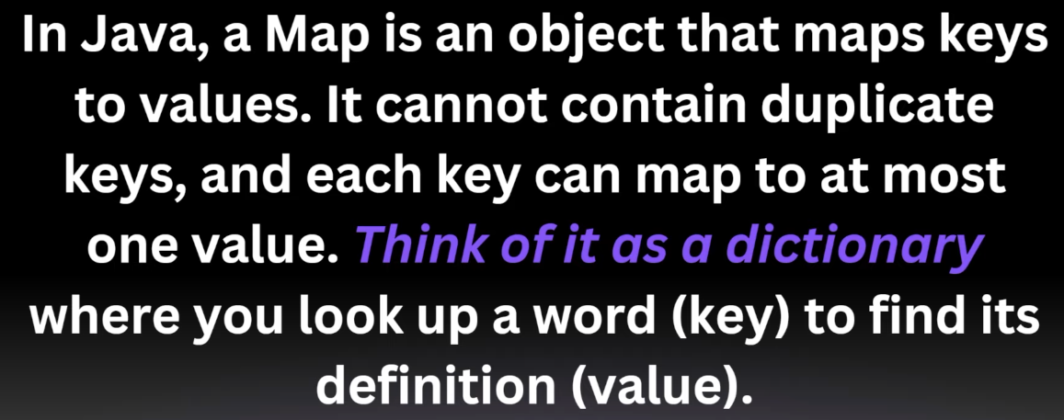



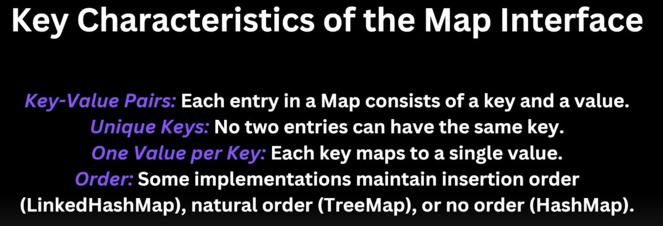

**HashMap**

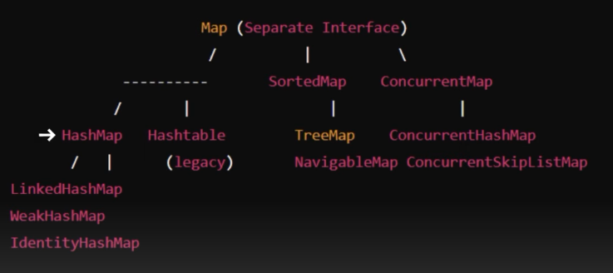

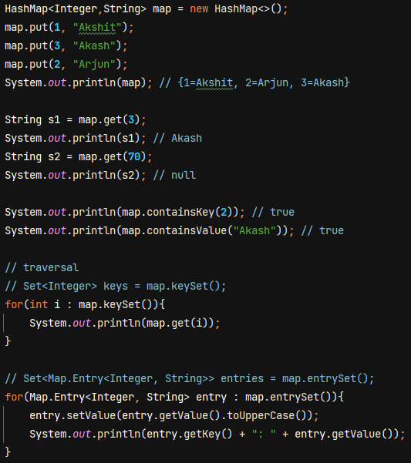

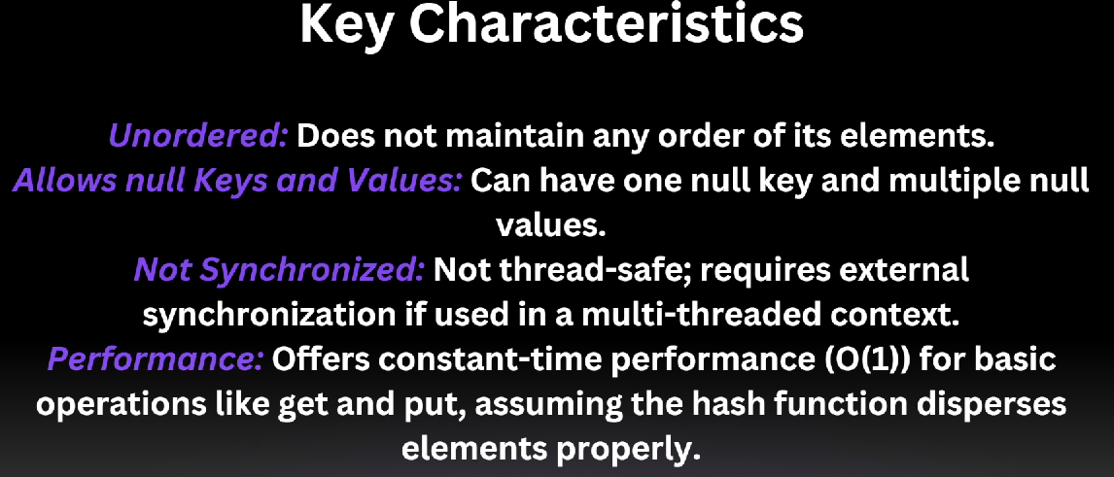

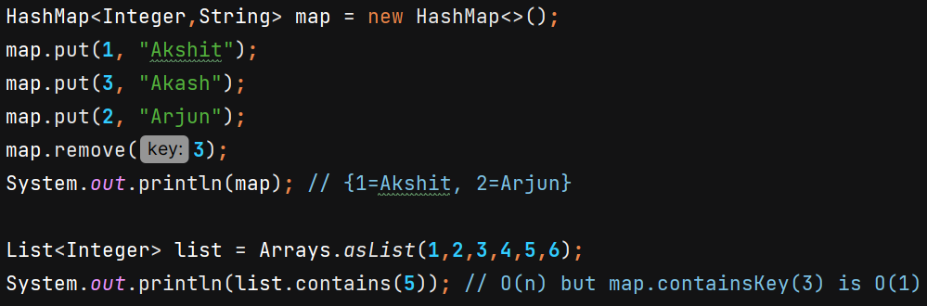

**Internal Working of Hashmap**

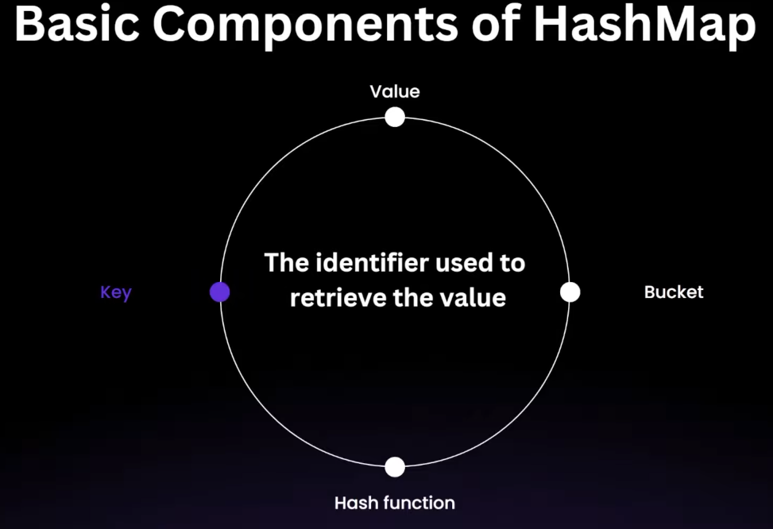

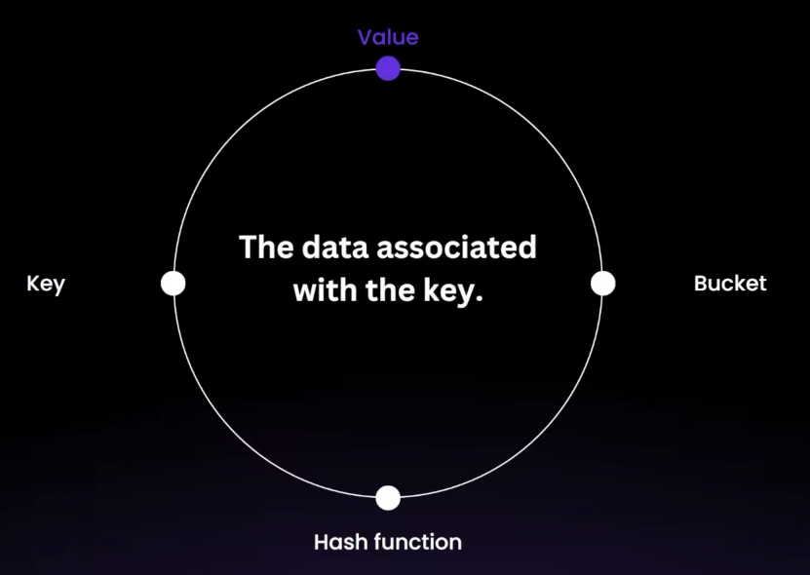

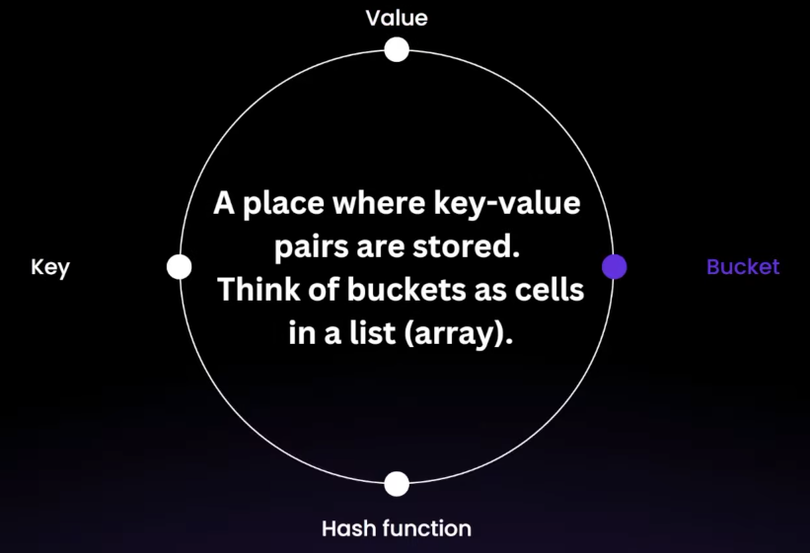

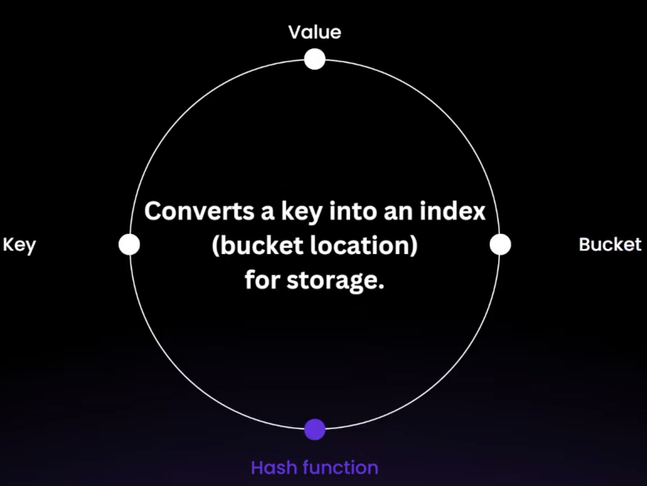

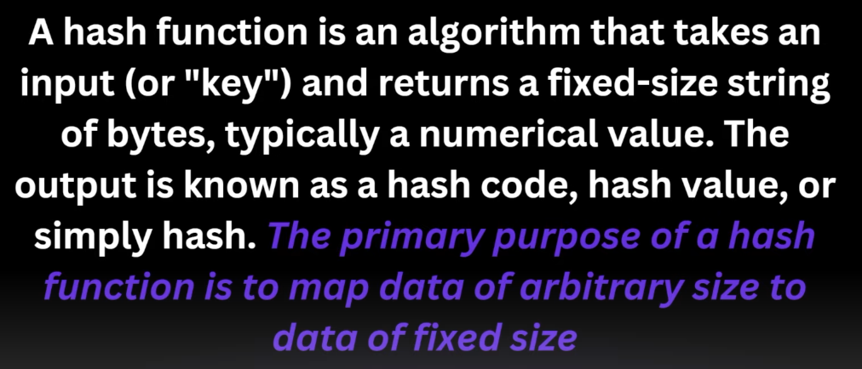

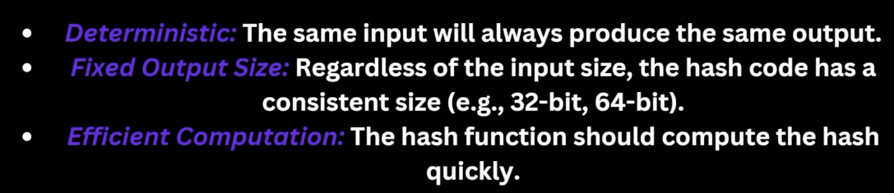

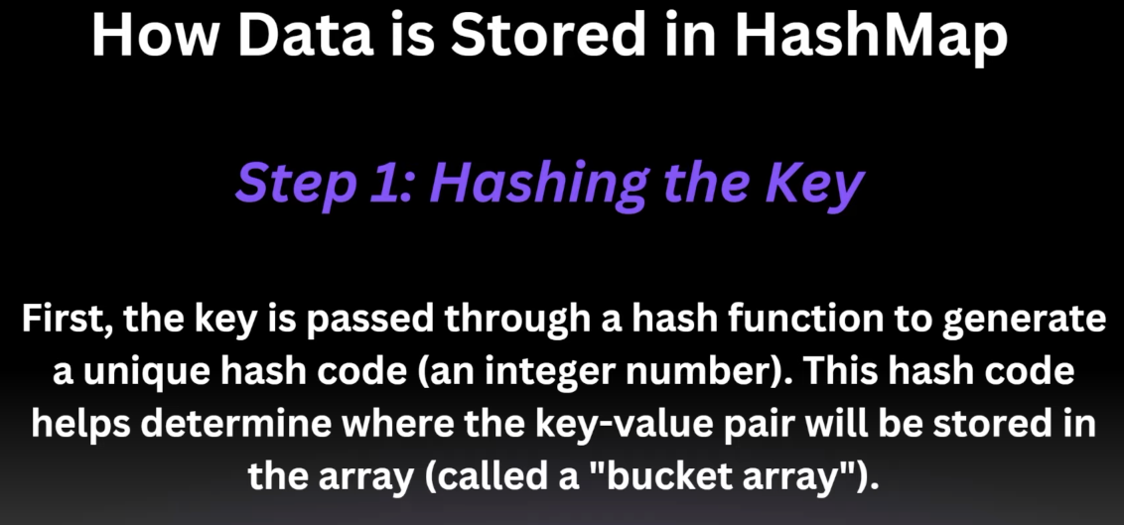

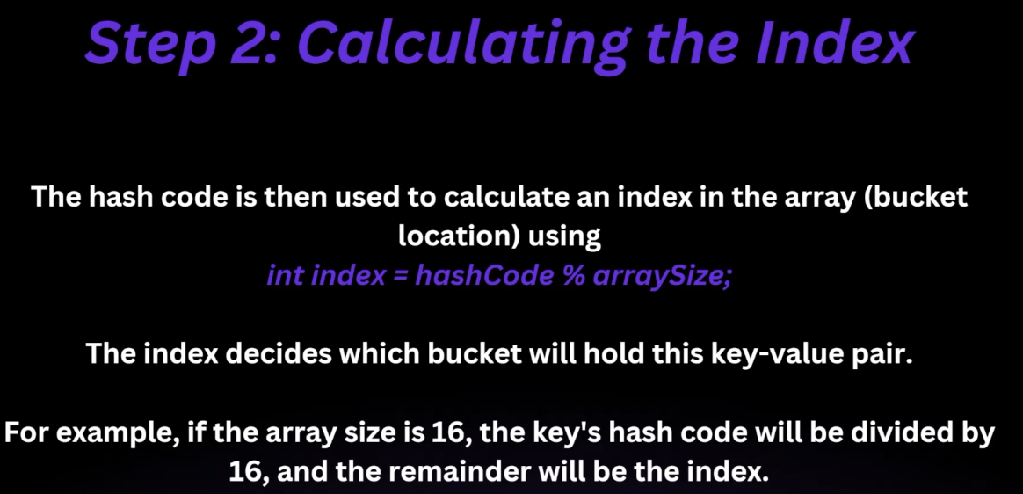

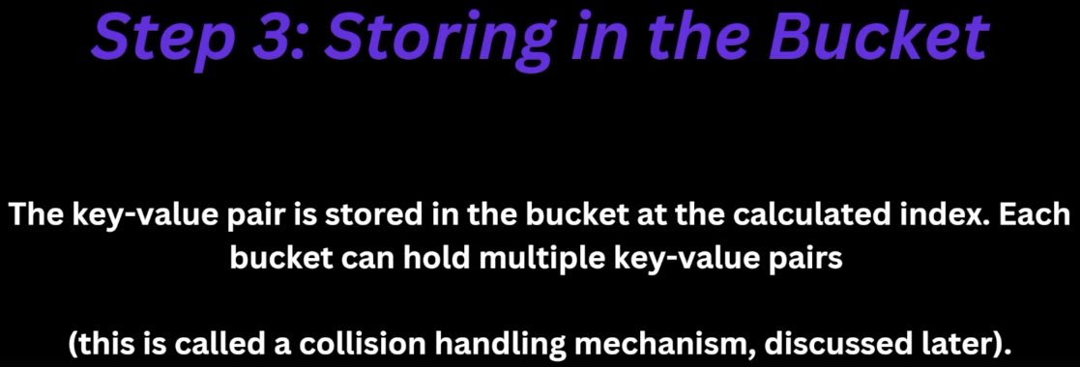

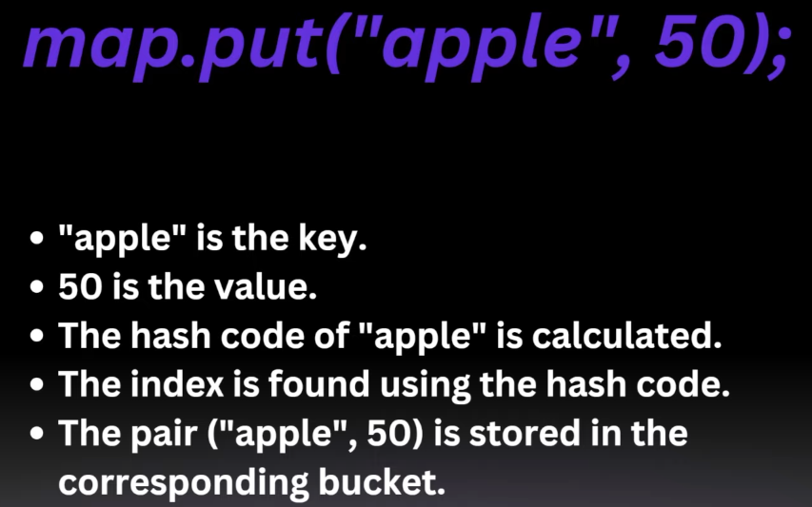

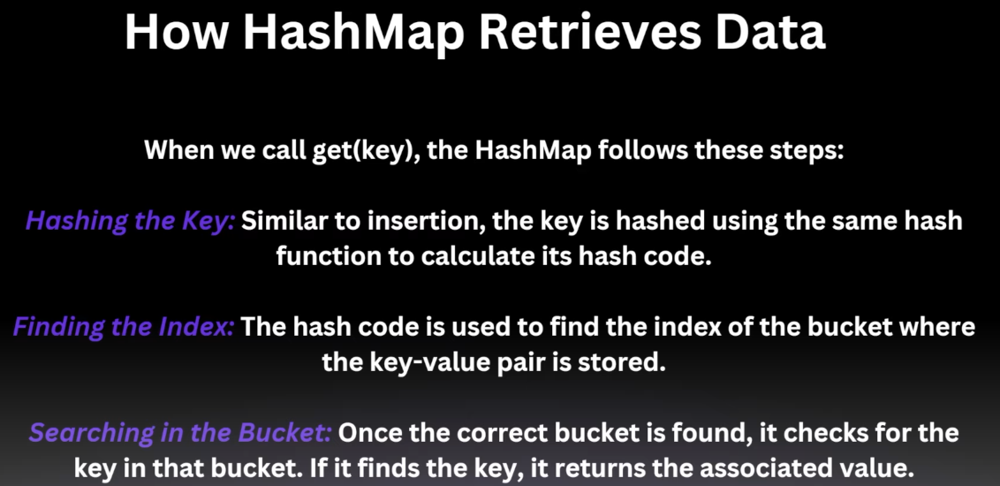



Hash function give same output for different inputs leading to collision.

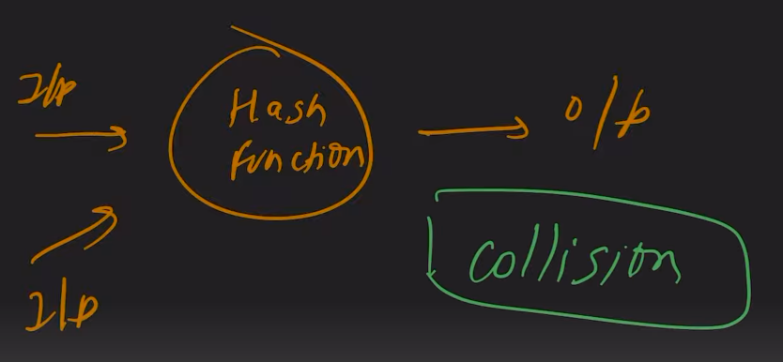

Bucket array is of type LinkedList

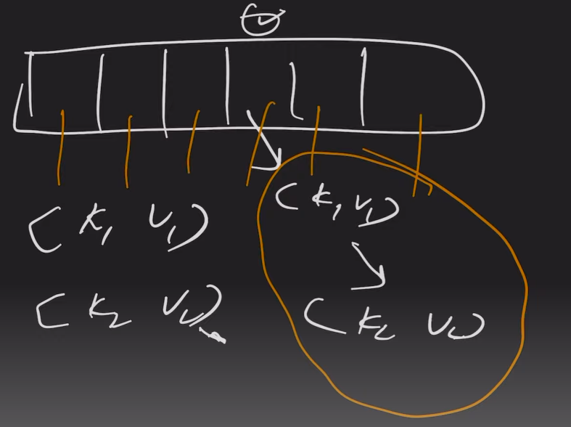

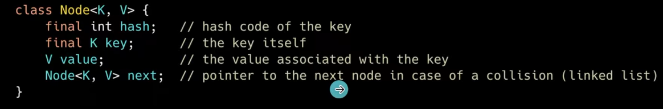

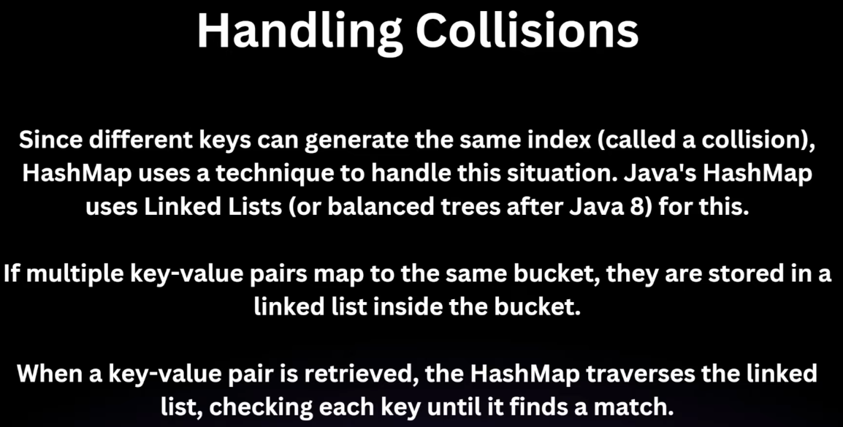

In worst case time complexity is O(n) as searching in LinkedList is linear.

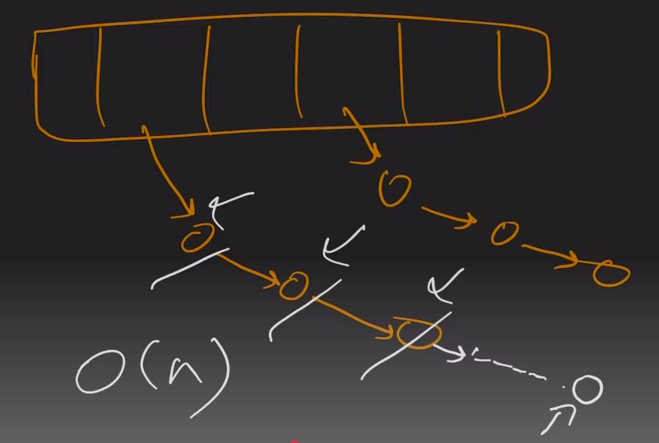

**After Java 8** :- When the linked list size crosses a certain threshhold, it is converted to Balanced Binary Search Tree (Red Black Tree). By default threshhold is 8.

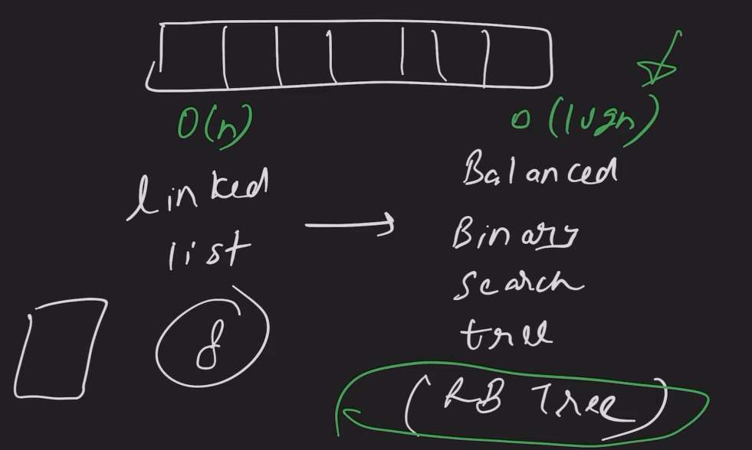

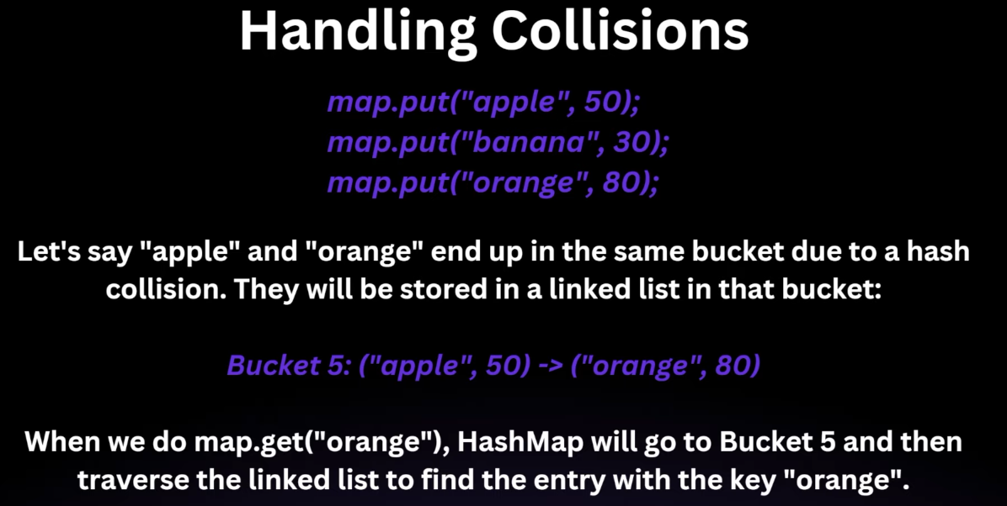

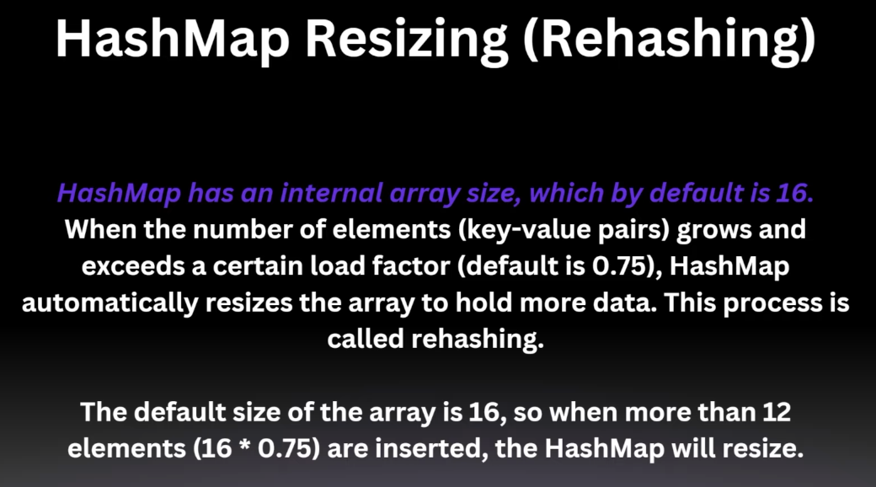

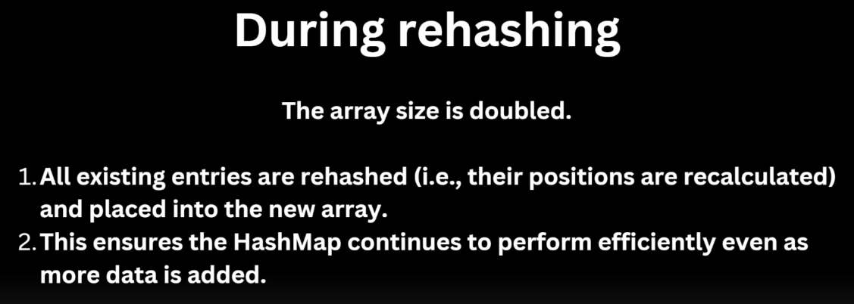



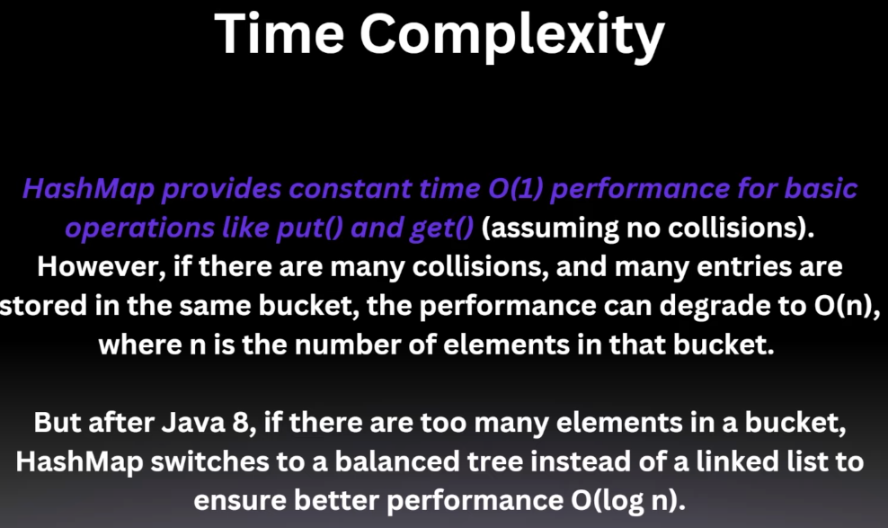

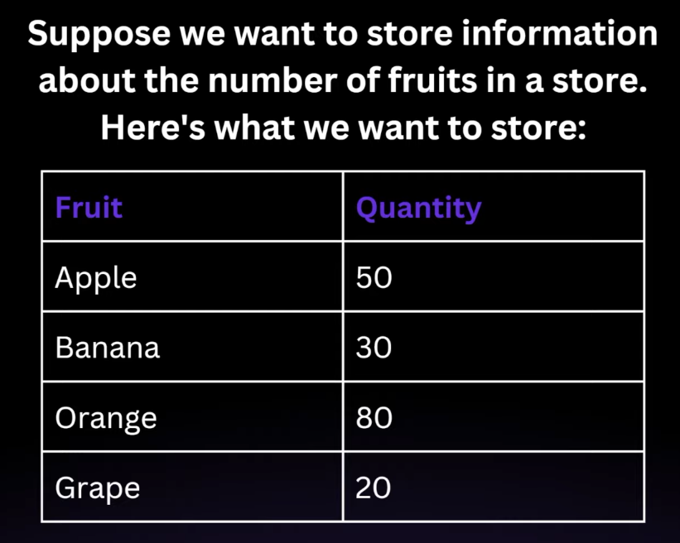



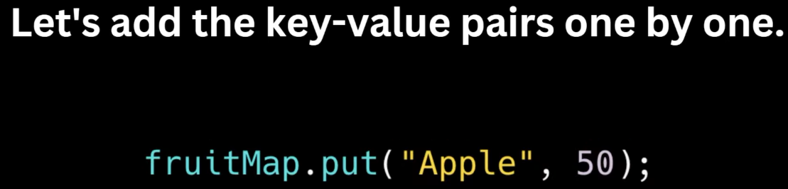

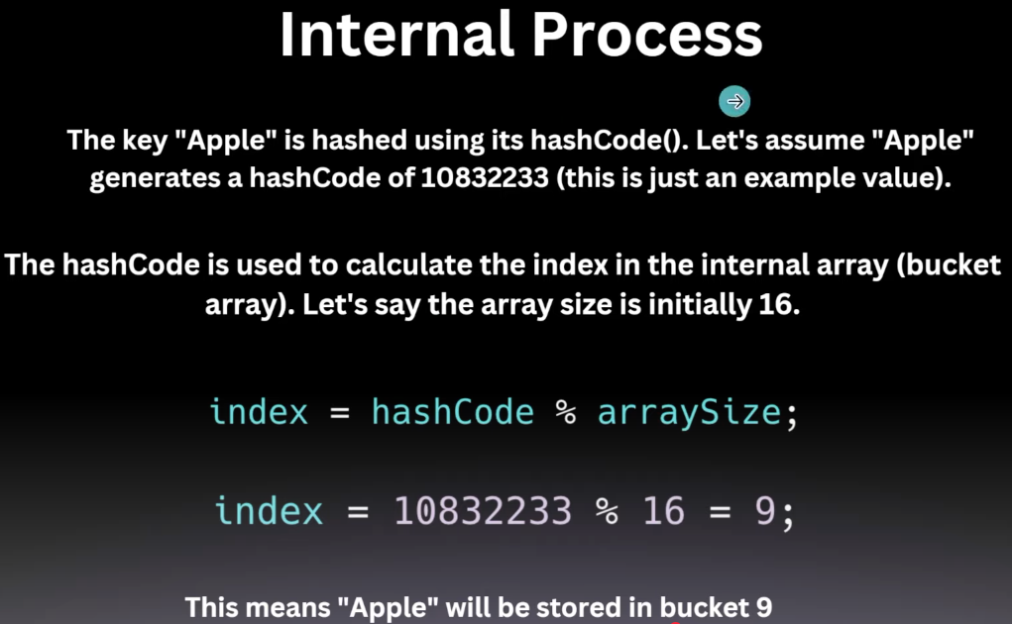

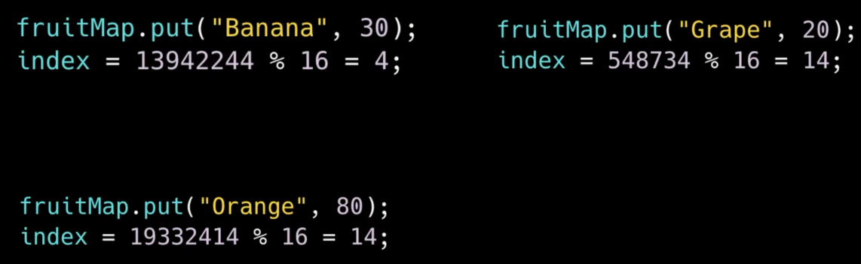

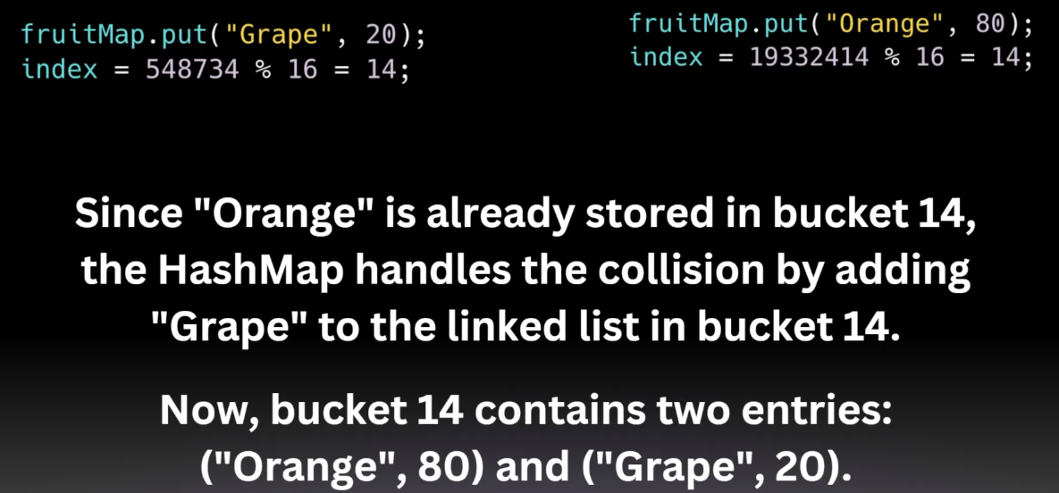

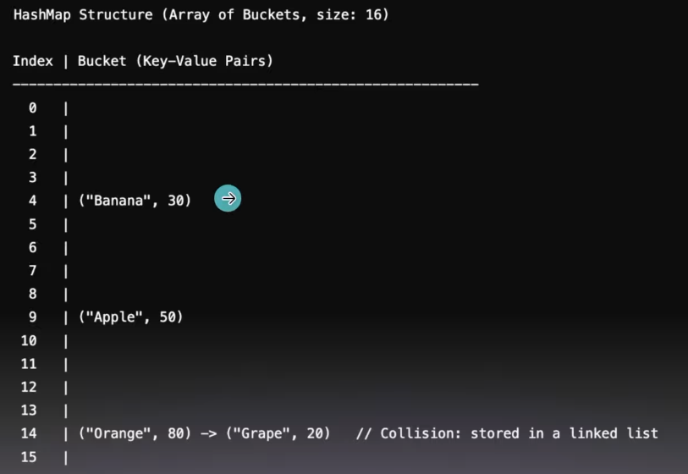

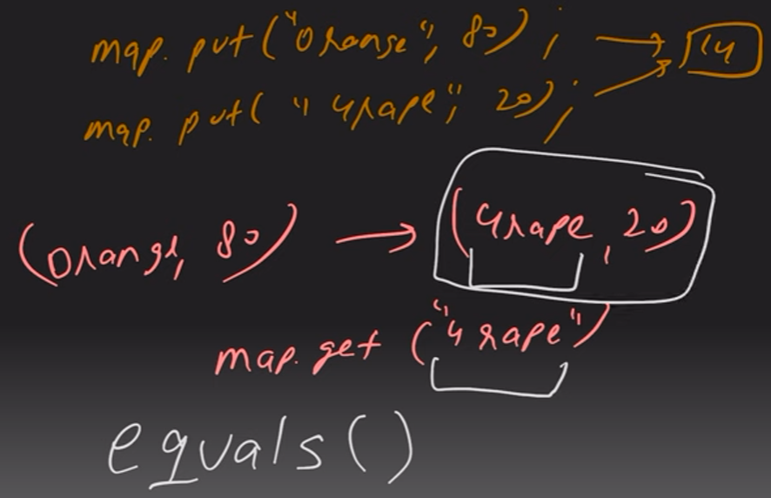

In above example, equals() method will be used to check String.

Another example –

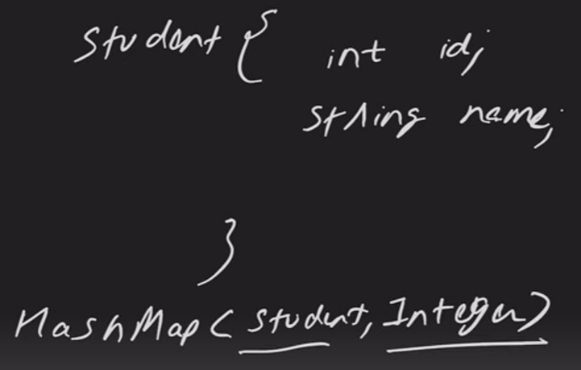 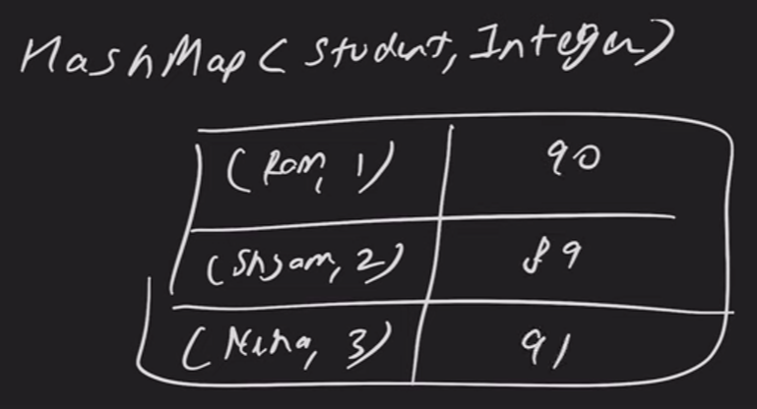

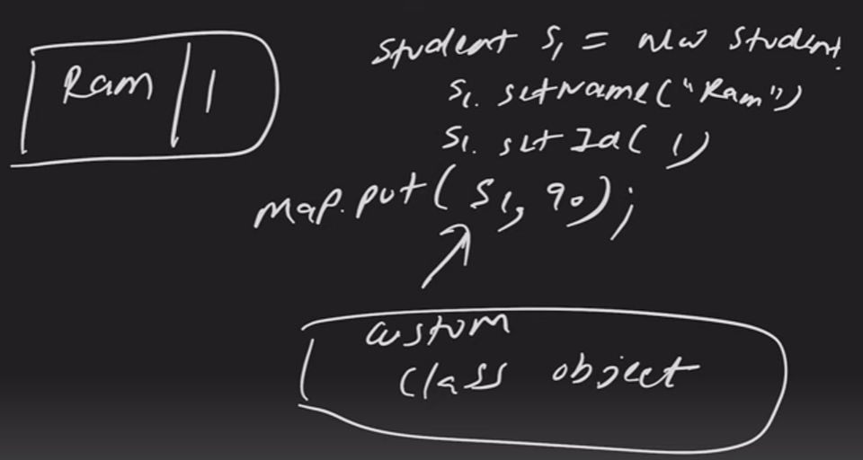

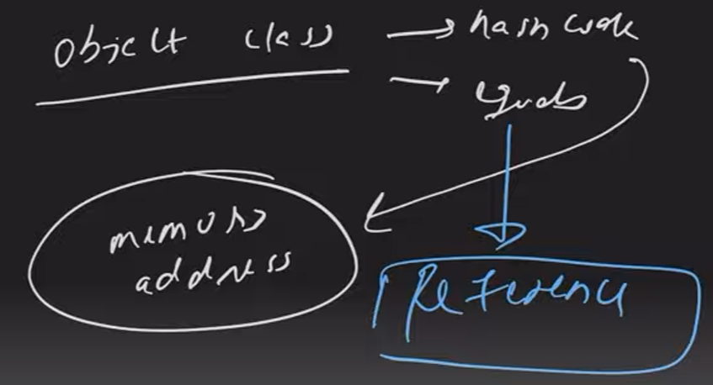

Every instance of student class will have different hashcode based on memory address.

The default implementation of equals() in Object checks for **reference equality**, which means it compares the memory addresses of the two objects.

The String class overrides the equals method to compare the **content** of the strings rather than their memory addresses.

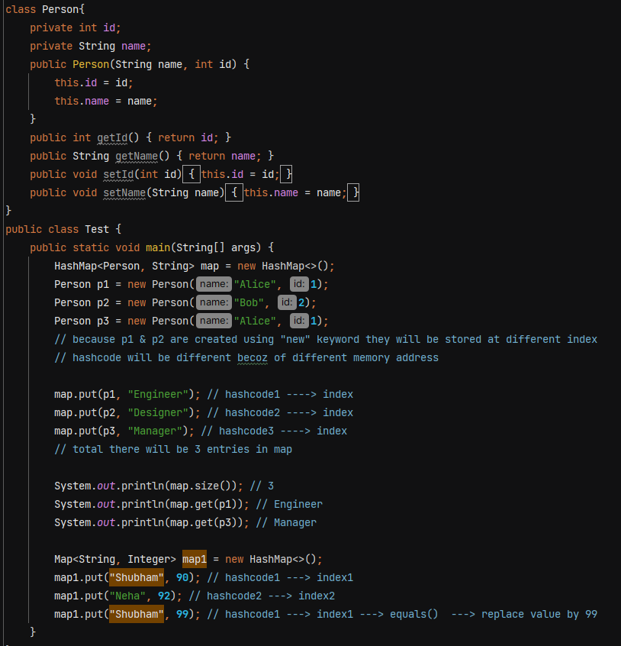

We want to make it understand that p1 & p2 both are same and their hashcode generate should be same. To do that we have to override hashcode() and equals() method. We also override these methods when storing custom class objects in Set.

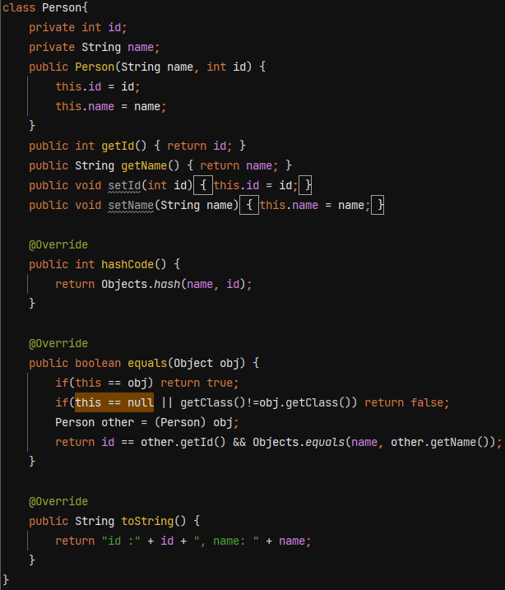

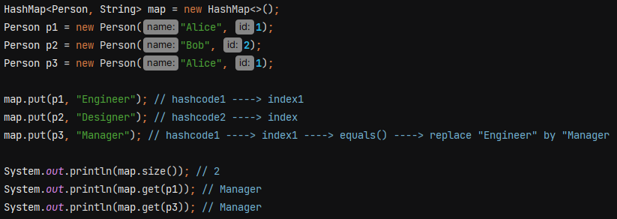

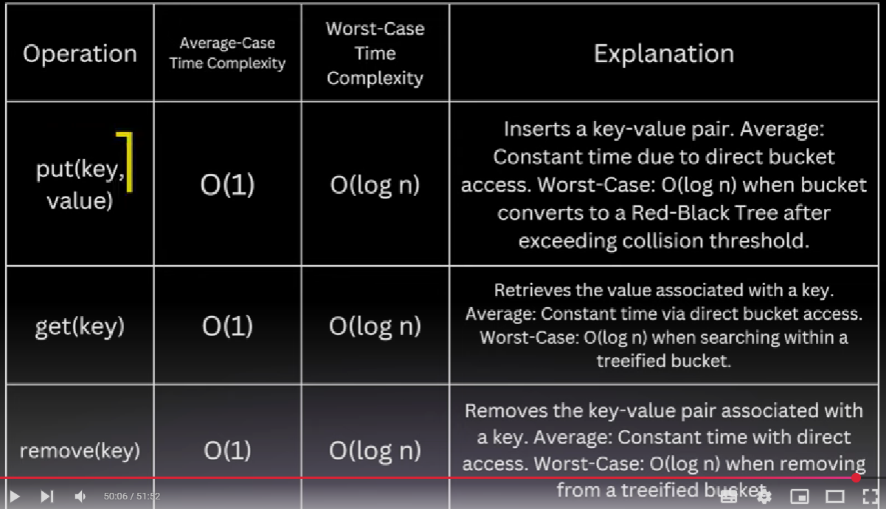

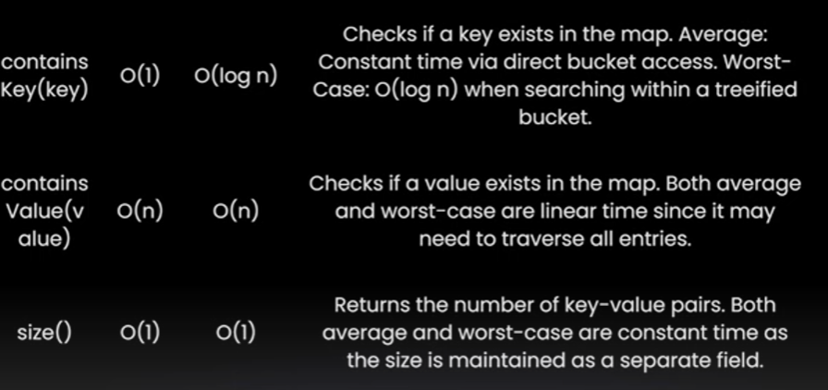

**LinkedHashmap –** order gets maintained, It is not threadsafe just like HashMap

LinkedHashmap has a double linked list that store all the entries inside it in the order in which you inserted. It is slower and takes more memory in comparison to hashmap.

Its constructor can take three values – initialCapacity, loadFactor and accessOrder

accessOrder is by default false. (which means storing as per insertion order, true for storign as per access order)



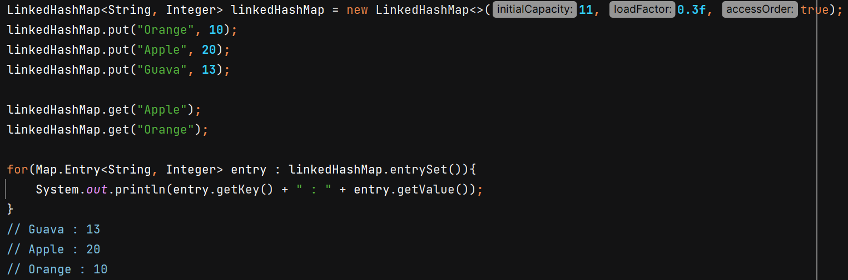

When accessOrder is true, it gives behaviour of LRU cache. Least recently used item is on starting and lastest used item on end. So we can remove the LRU items from top.

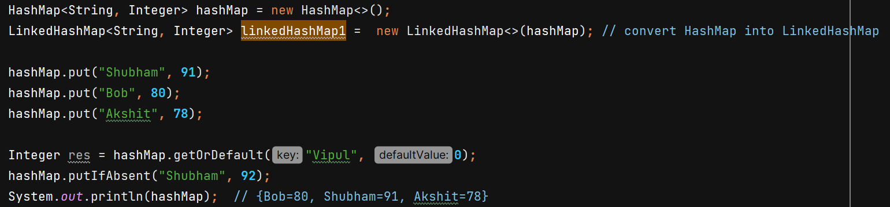

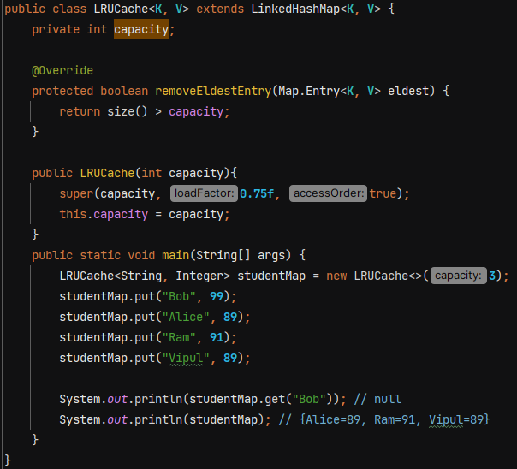

**WeakHashMap**

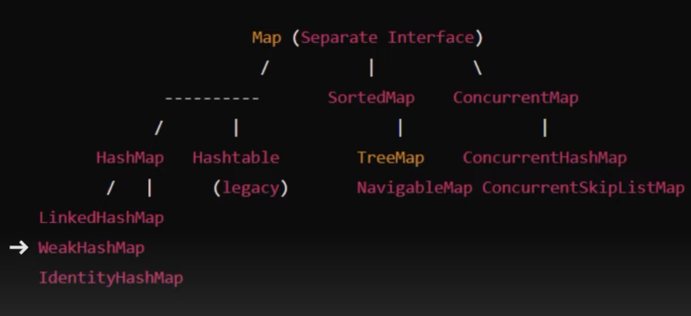

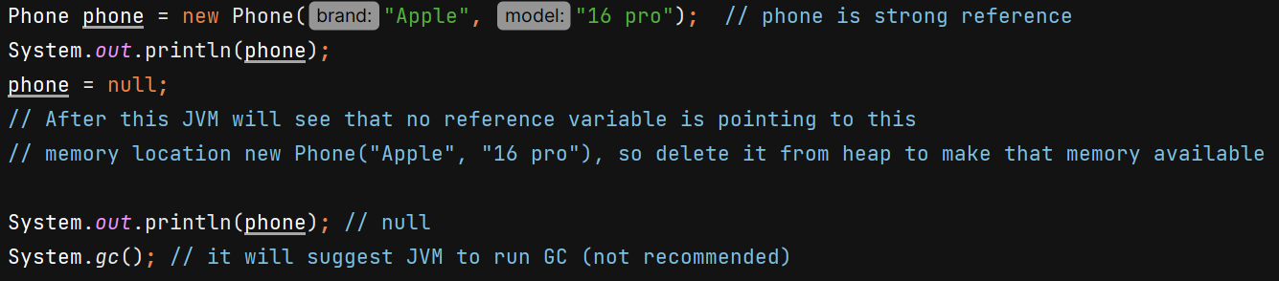

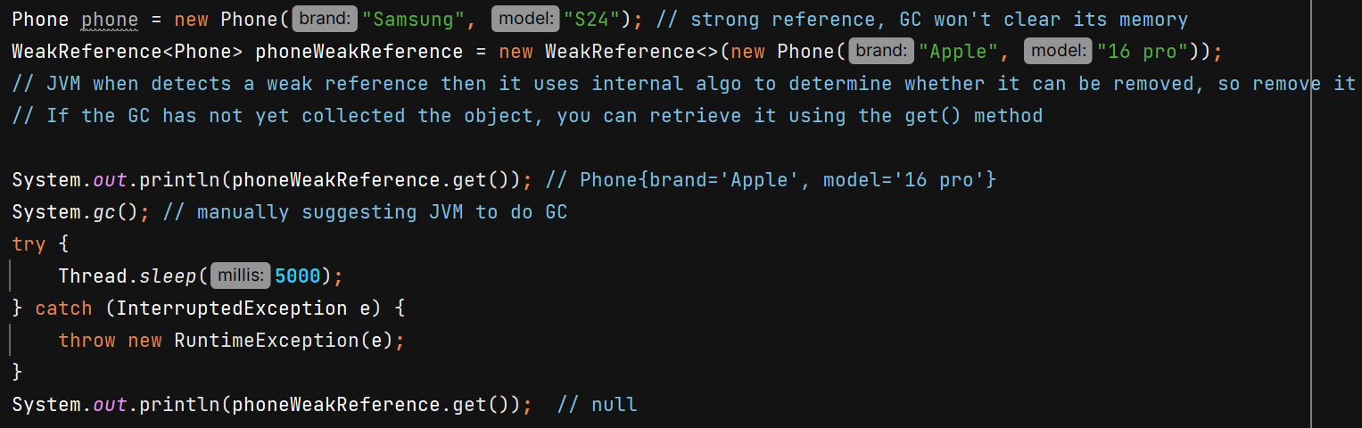

An entry in a WeakHashMap will automatically be removed when its key is no longer in ordinary use.

String literals are stored in string pool due to which they are strong referenced throughout the lifecycle of program. That’s why if we use key as string literal then it won’t be removed after GC run.

Example with non literal string –

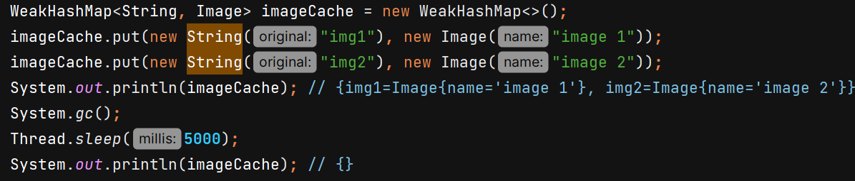

**IdentityHashMap**

equals method of the String class in Java is overridden to compare **the content** (logical equality) of two strings rather than their memory addresses.

The overridden hashCode method in the String class computes the hash code based on the content of the string, rather than its memory address.

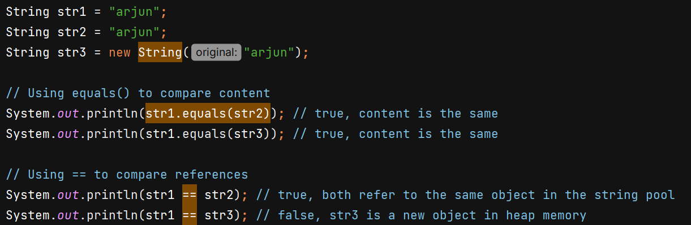

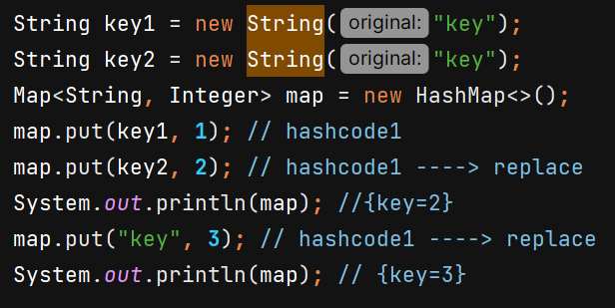

Whether in ur class u override the hashcode or not. In identityHashMap only the hashcode of Object class will be used which generate hashcode based on memory address. And it won’t use equals() method to compare but it uses == operator which will check memory address.

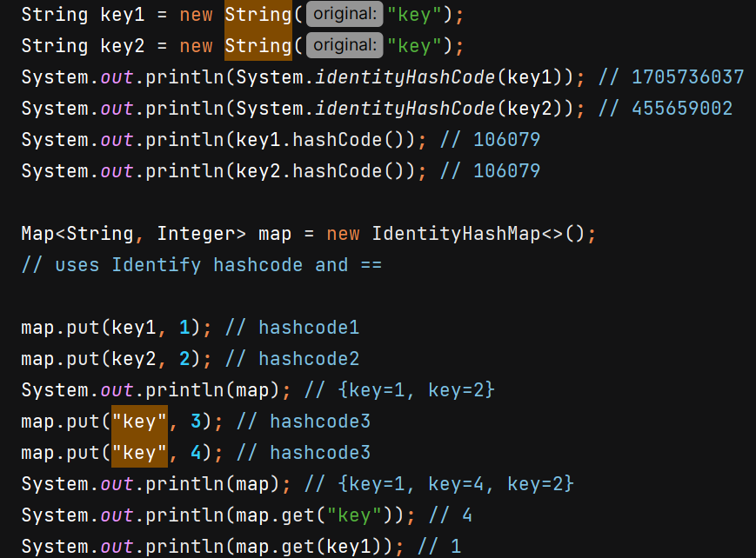

**Comparable** – used for sorting of class

Comparator is used when we need to give custom logic.

list.sort(null) means we want natural ordering. For that class needs to implement Comparable<T> interface and implements compareTo() method and write sorting logic inside it. U can sort only based on 1 criteria. Using Comparable we set natural ordering mechanism for classes.

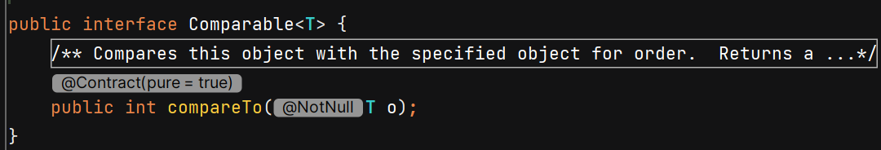

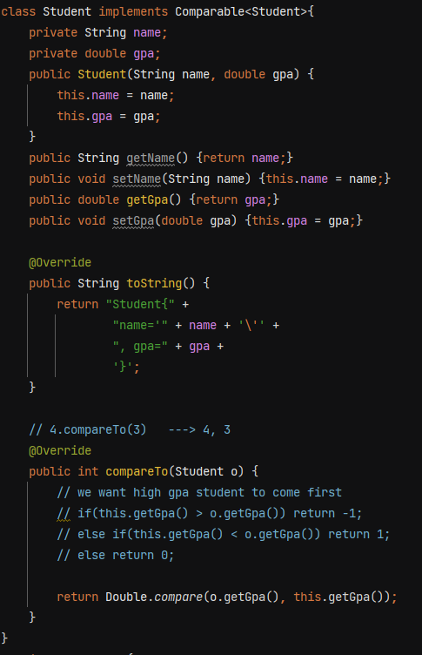

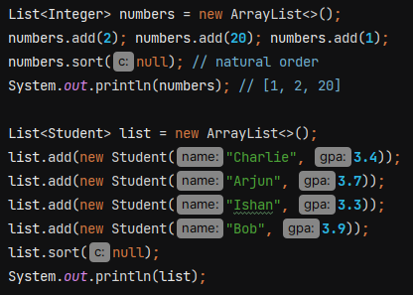 O/P – descending order of gpa

**SortedMap** – its an interface and TreeMap is its implementation



Null key is not allowed as sorting can’t happen, it will throw NPE

TreeMap internal implementation is Red Black tree which is self balancing binary search tree.

Time complexity = O(logn)

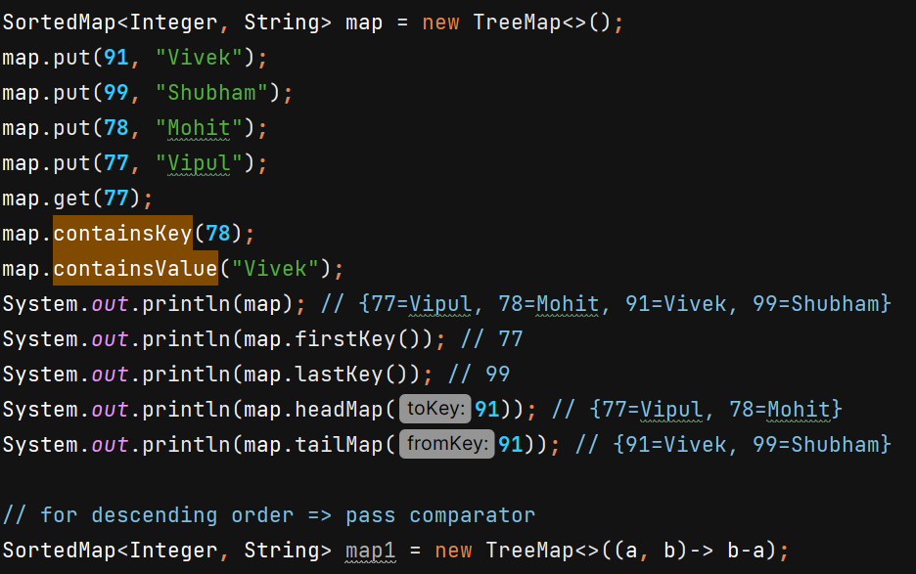

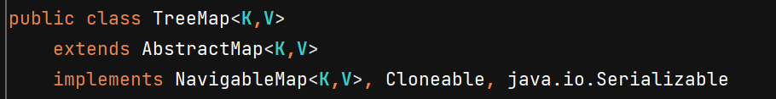



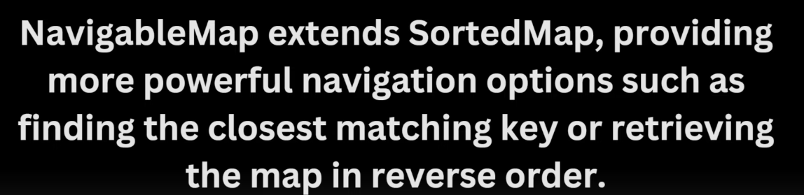

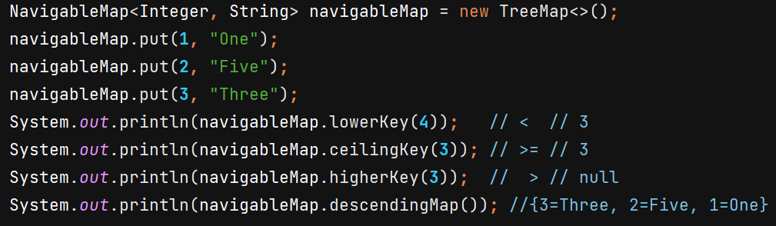

**Hashtable**

* All methods are synchronized (get, put, etc..)
* No null key or value
* Replaced by ConcurrentHashMap
* Slower than HashMap
* Implements Map
* Only LinkedList used in case of collision no RBT

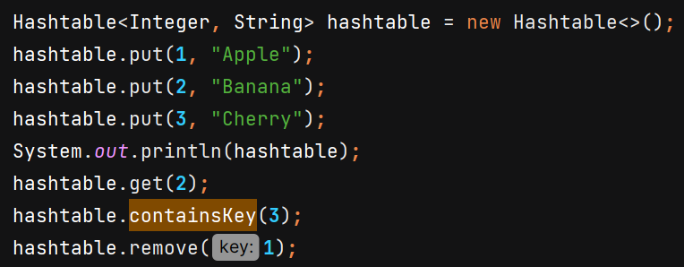

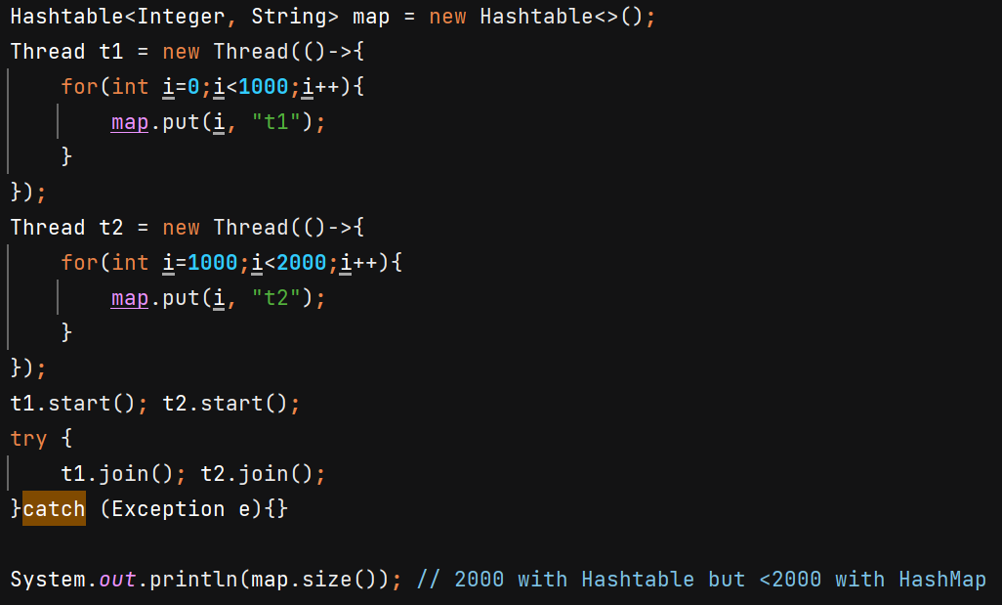

**ConcurrentHashMap**

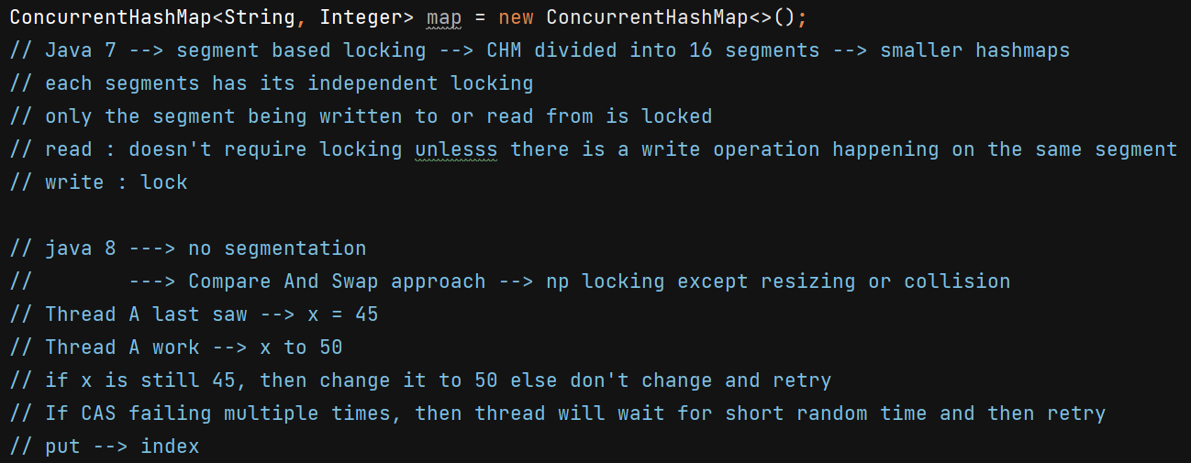

**ImmutableMap** – cannot change the content once instantiated

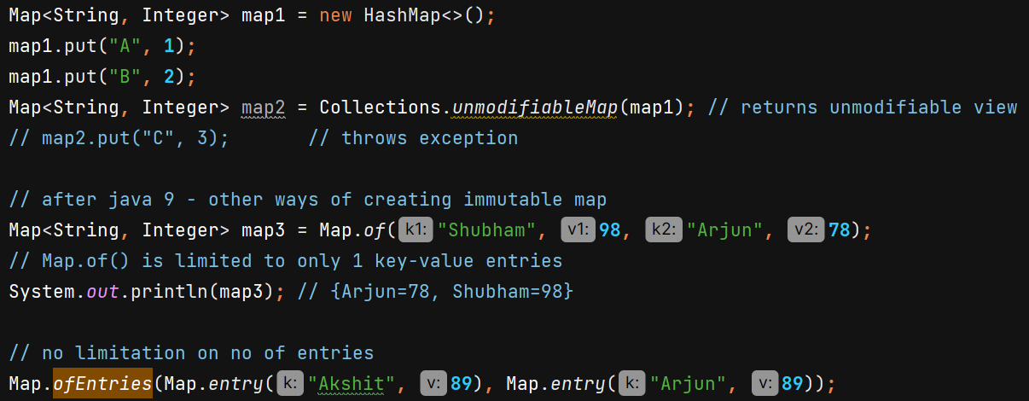

**EnumMap** –

* directly implements map interface
* knows all possible keys in advance , is more efficient compared to HashMap
* No hashing needed, valeus directly mapped to ordinal/index
* Maintians order of the enum constants' ordinal values

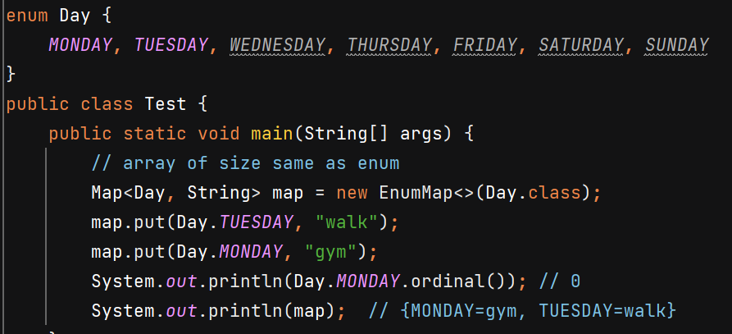

**ConcurrentSkipListMap** –

* sorted and thread safe
* data entry stored in skiplist data structure

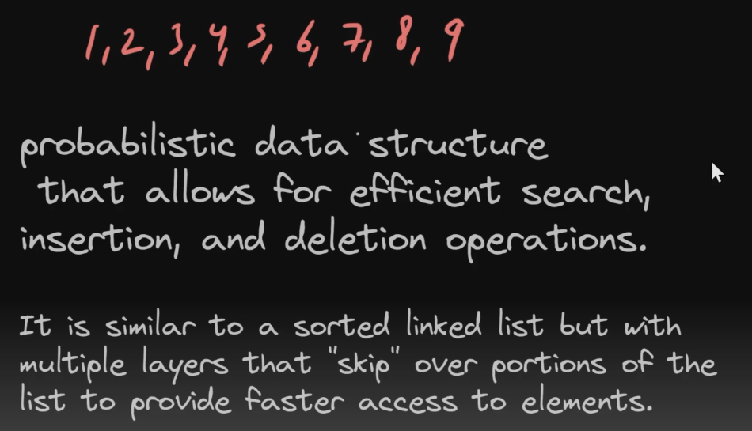

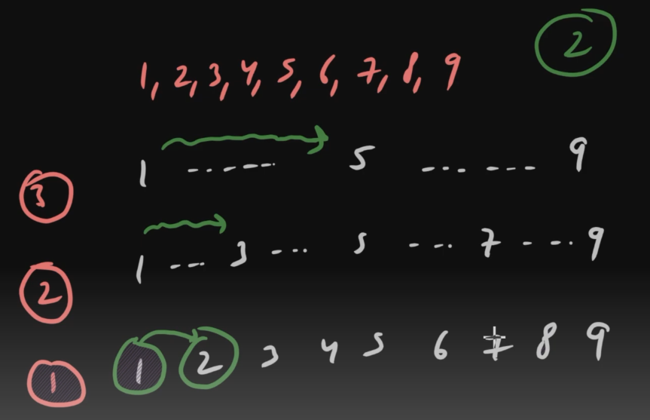







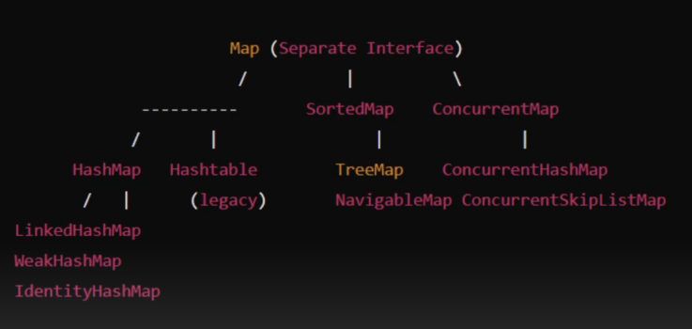

**Streams**

* Java 8 -> minimal code, functional programming (treating function as variable)
* new features -> lambda expression, Streams, Date & Time API

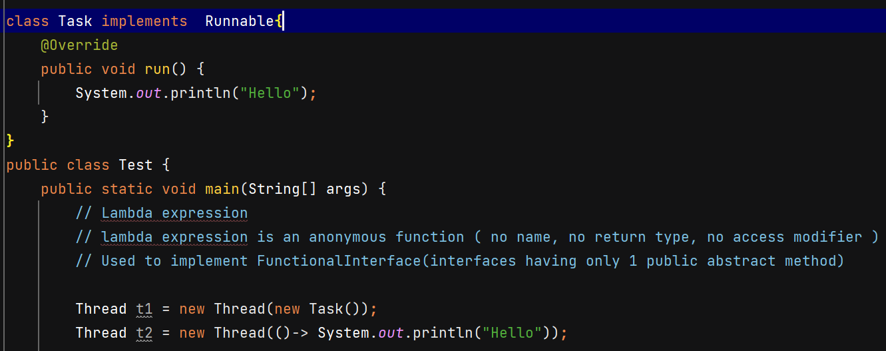

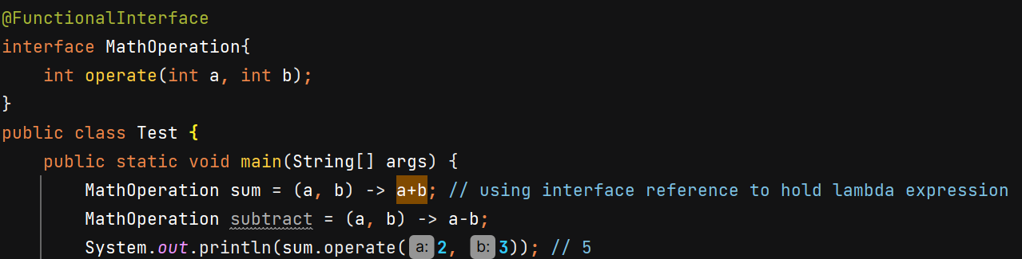

Predicate 🡪 functional interface (boolean valued function)

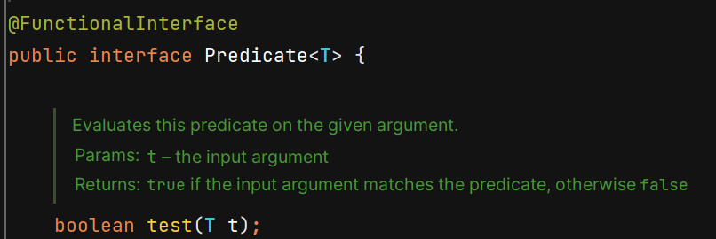

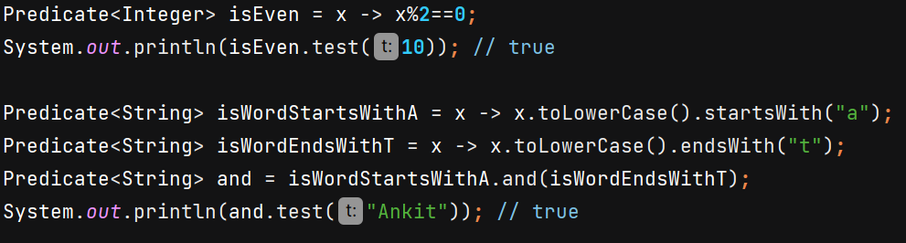

Function 🡪 work for you

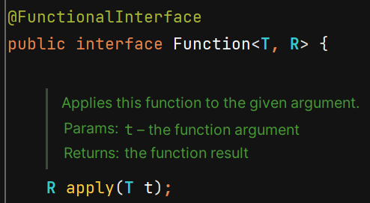

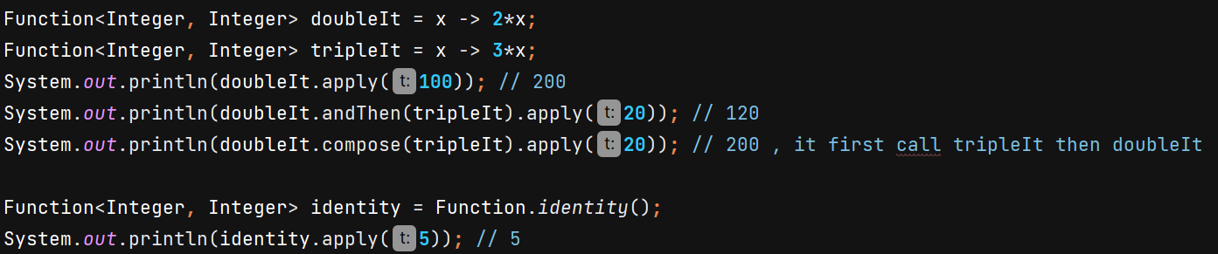

Consumer 🡪 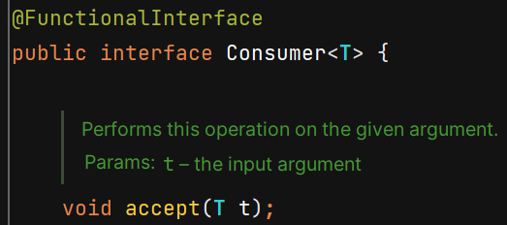

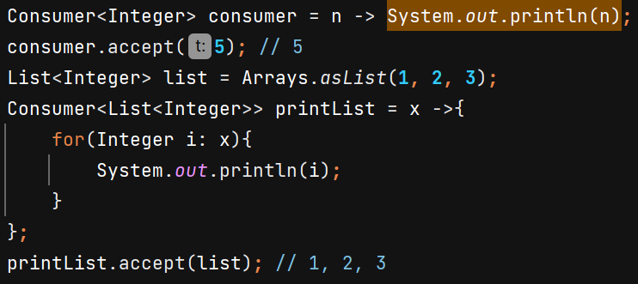

Supplier 🡪 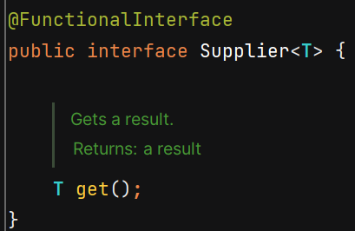



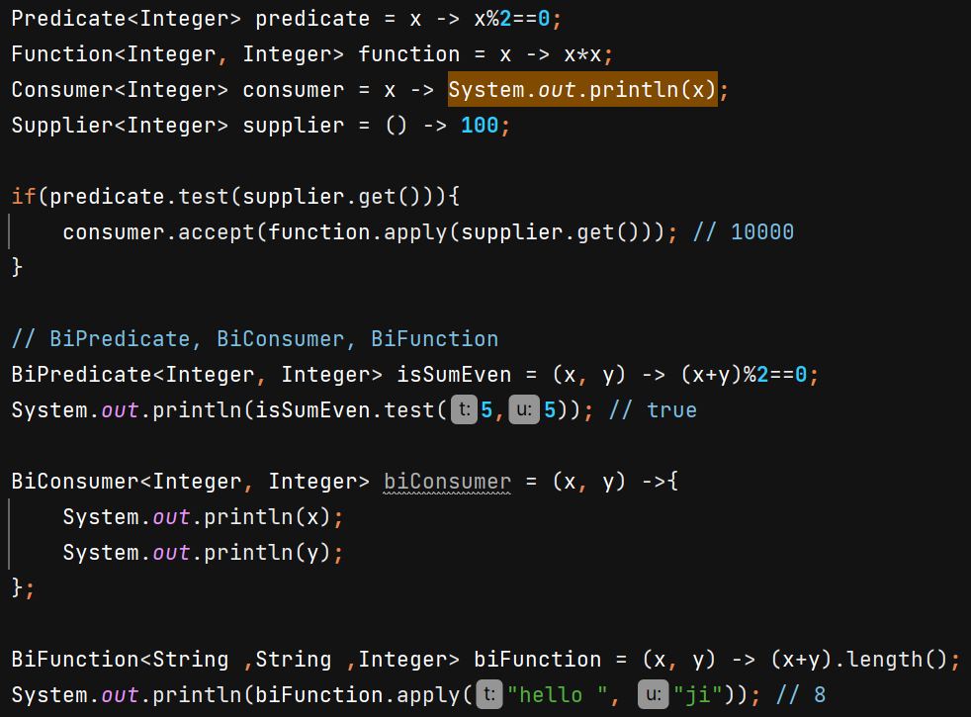

UnaryOperator 🡪 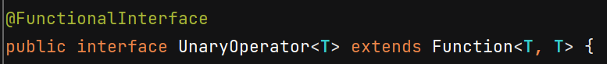

BinaryOperator 🡪 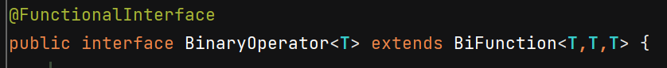

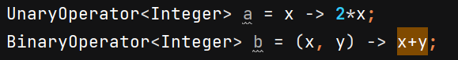

**Method Reference** 🡪 use method without invoking & in place of lambda expression

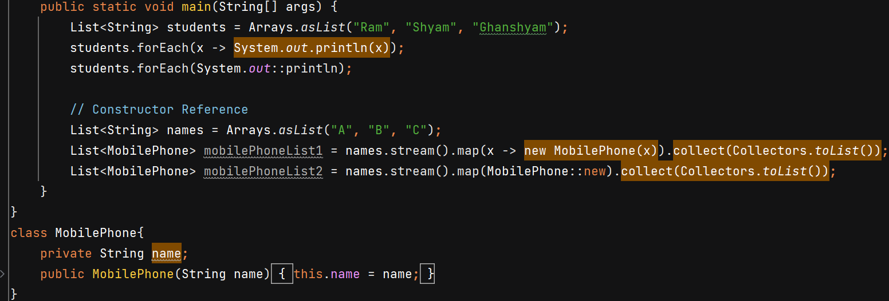

**Streams**

* process collections of data in a functional and declarative manner
* Simplify Data Processing
* Improve Readability and Maintainability
* Enable Easy Parallelism
* How to Use Streams ?  
  Source**,** intermediate operations & terminal operation

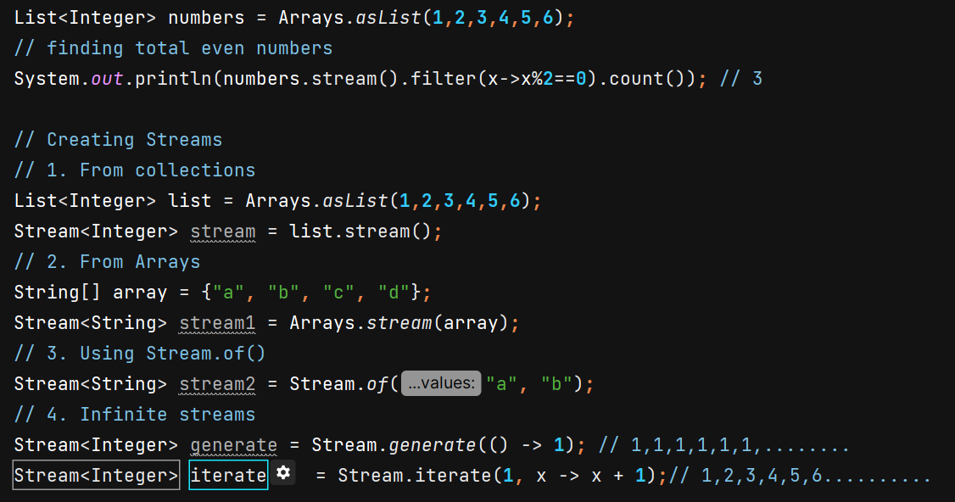

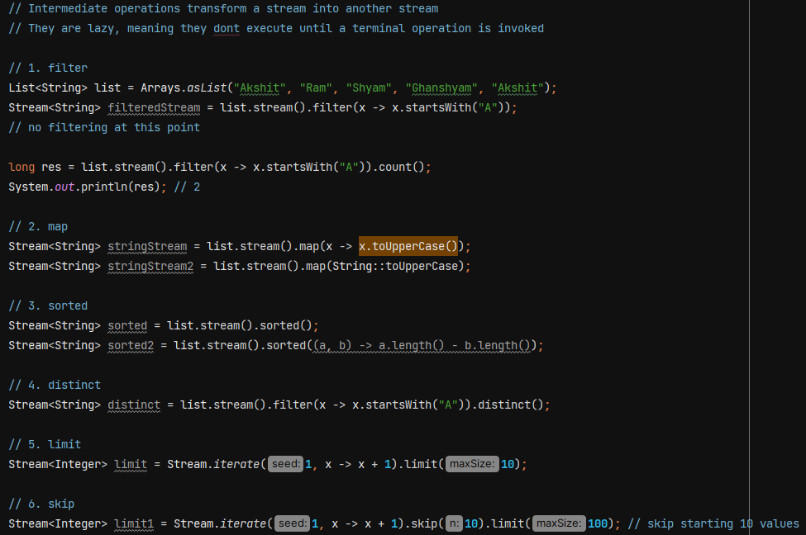

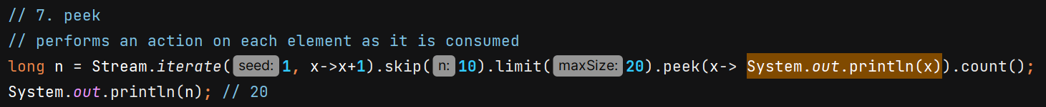

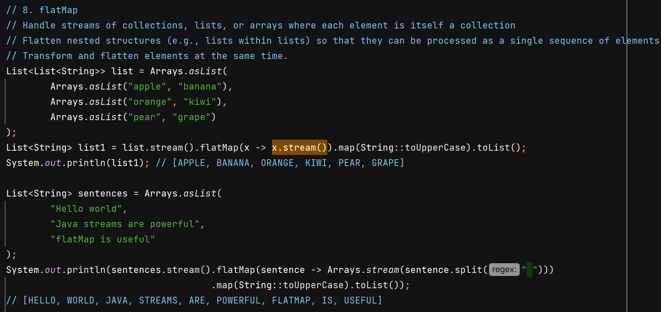

Terminal operators –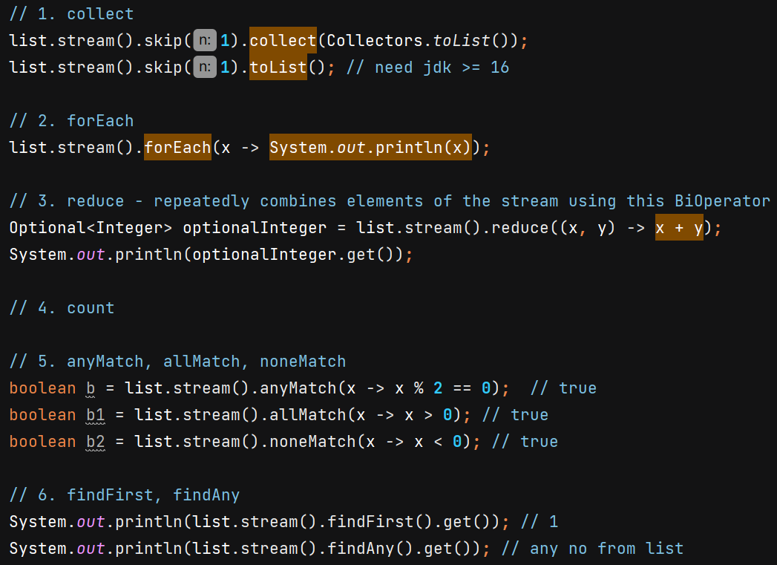

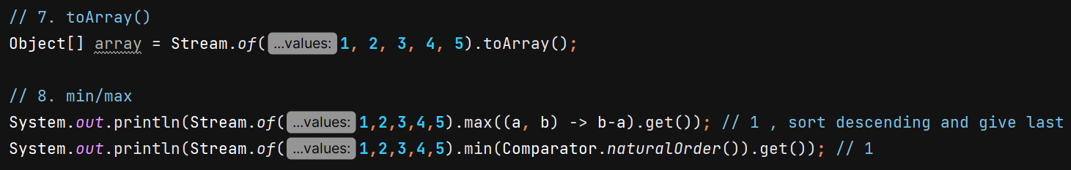

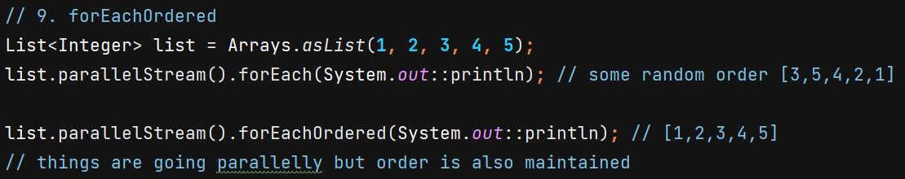

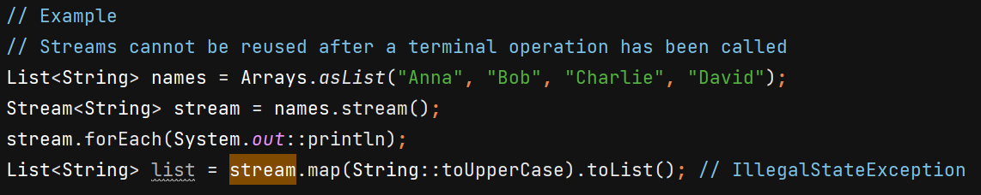

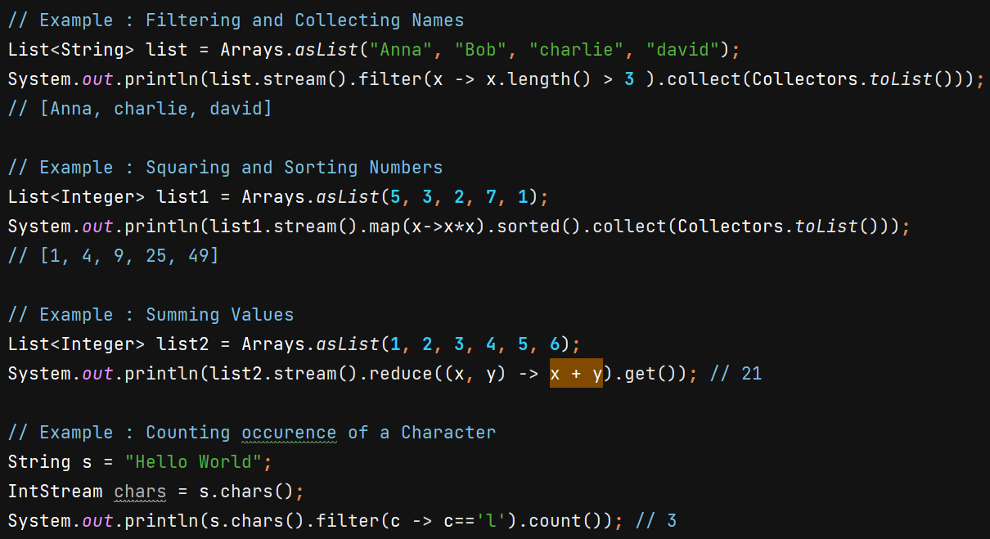

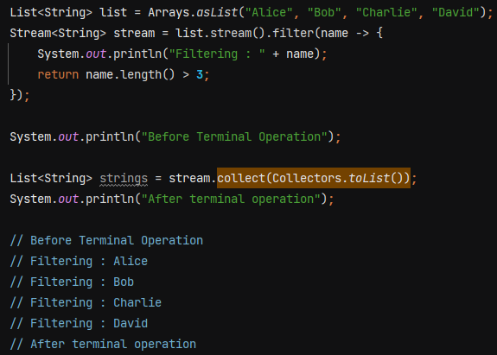

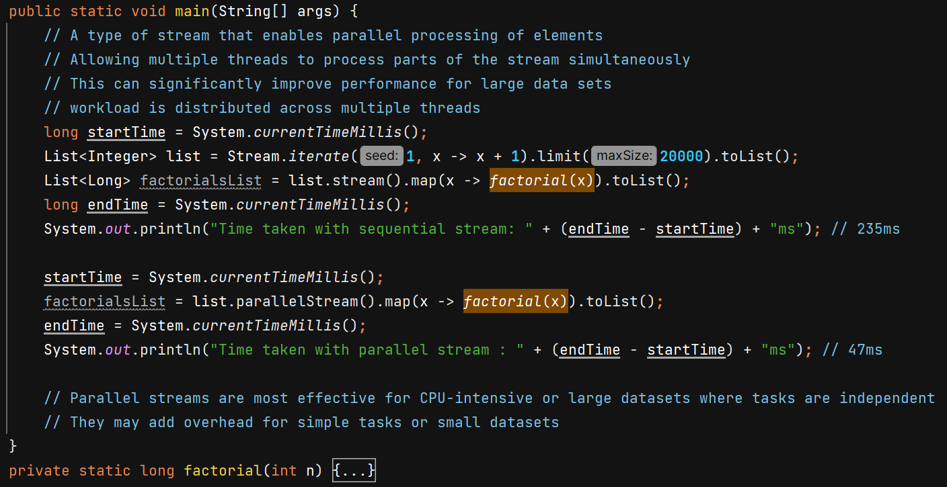

We can convert parallelStream to sequential –



parallelStream don’t work here -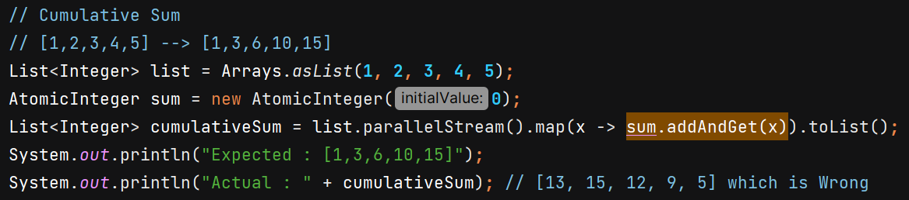

**Collectors** – It is a utility class which provides a set of method to create a common collectors

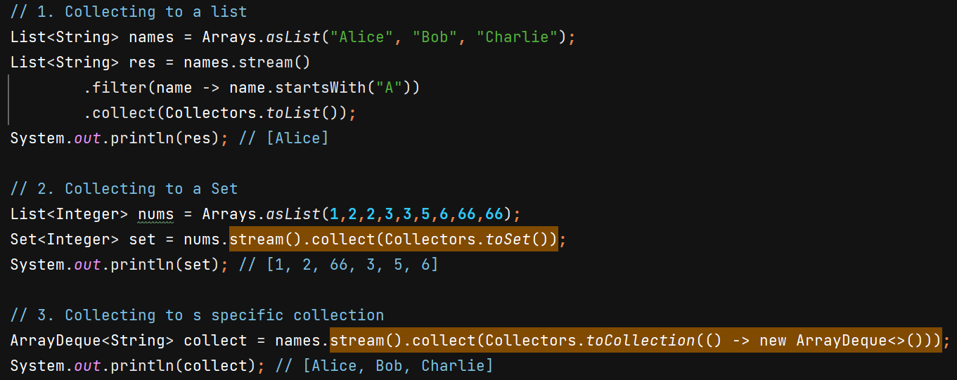

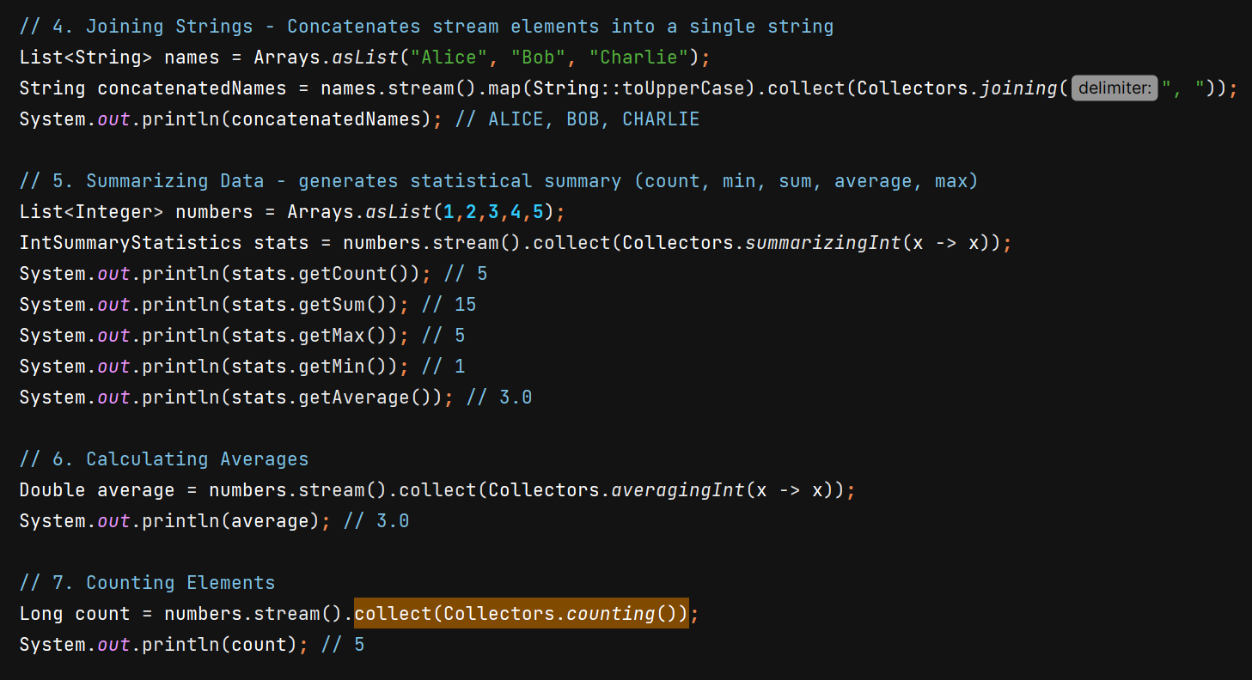

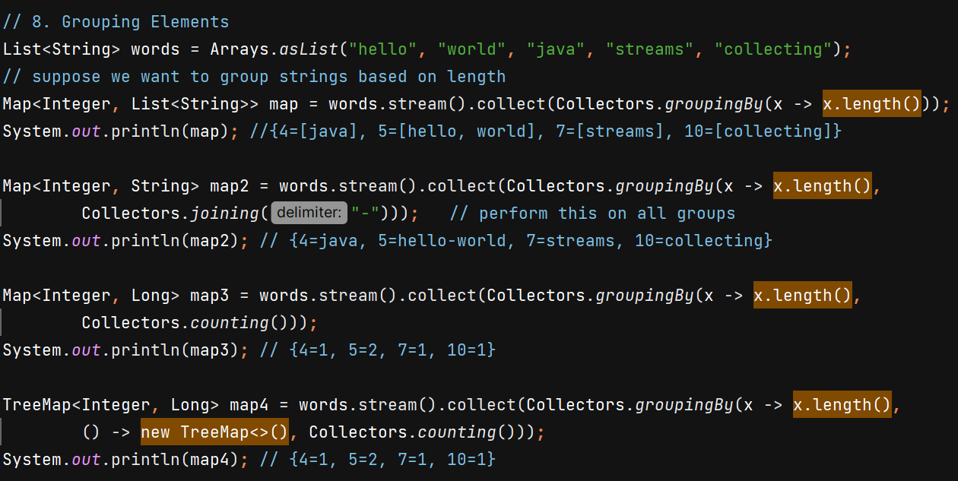

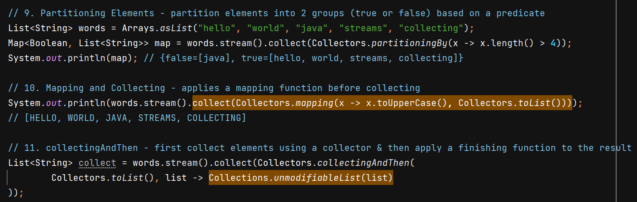

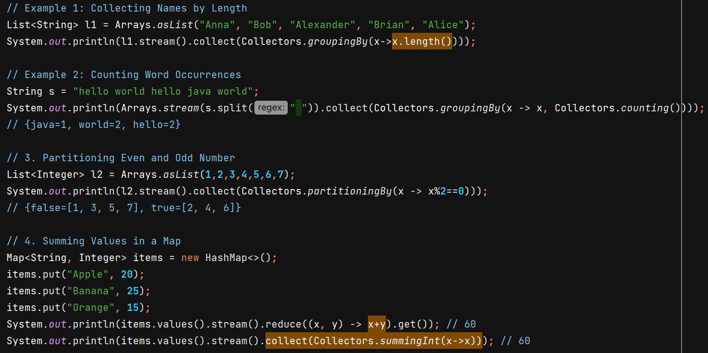

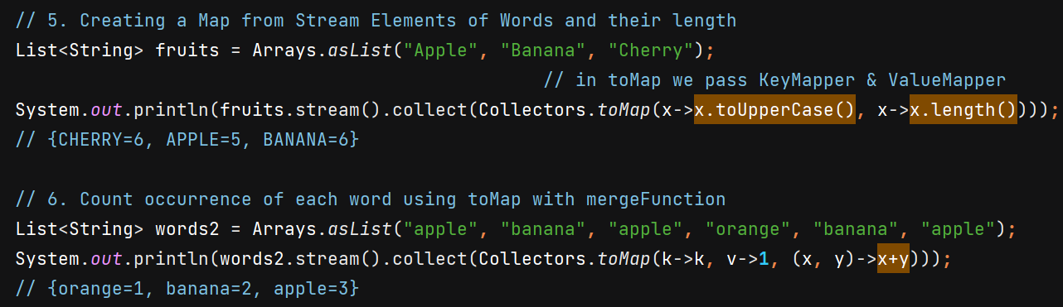

**Primitive Streams**

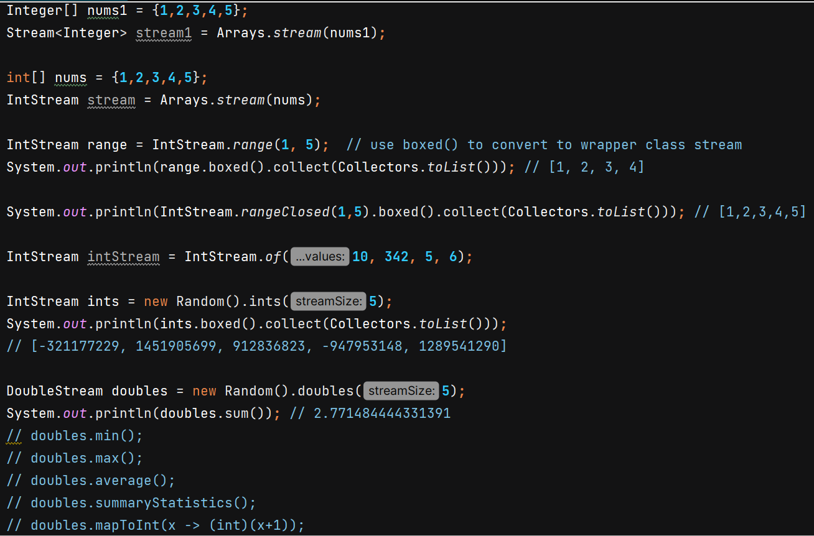

**Iterator** – used to traverse over the Collection

we are able to use for each loop in ArrayList because of it implements Iterable interface and provides implementation of iterator().

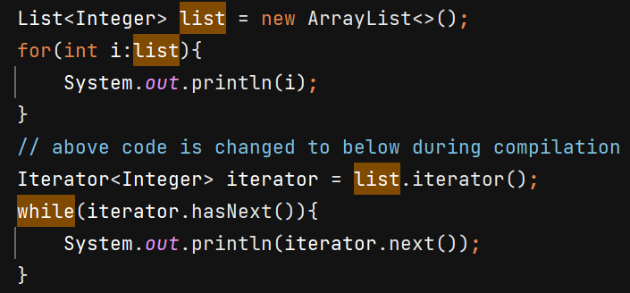

Iterator provides functionality of removing while iterating –

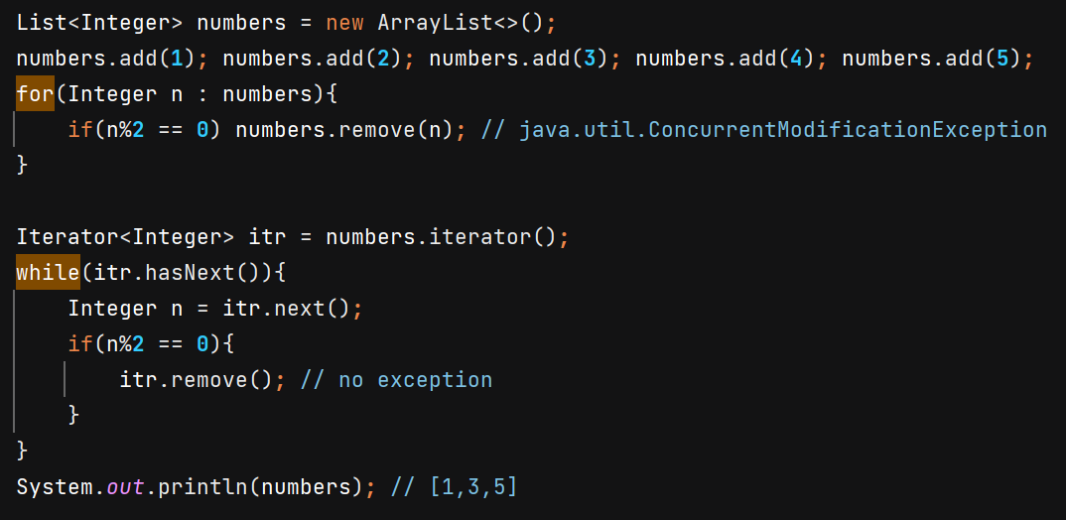

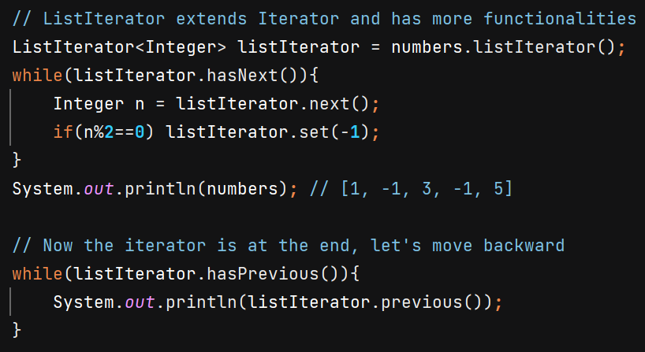

**Sets** 

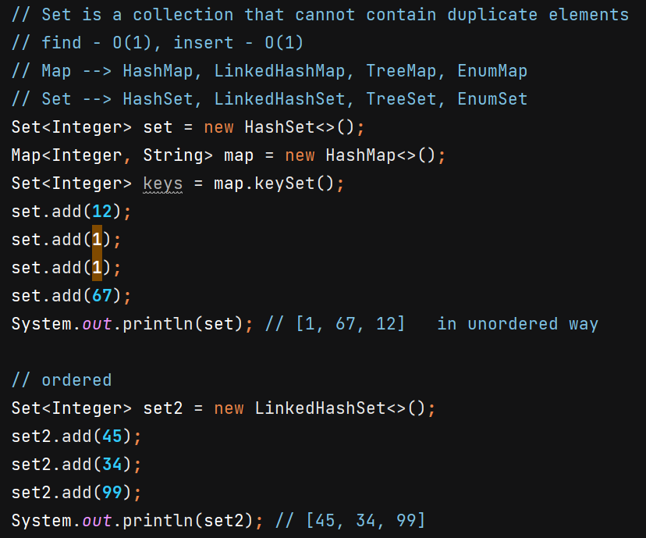

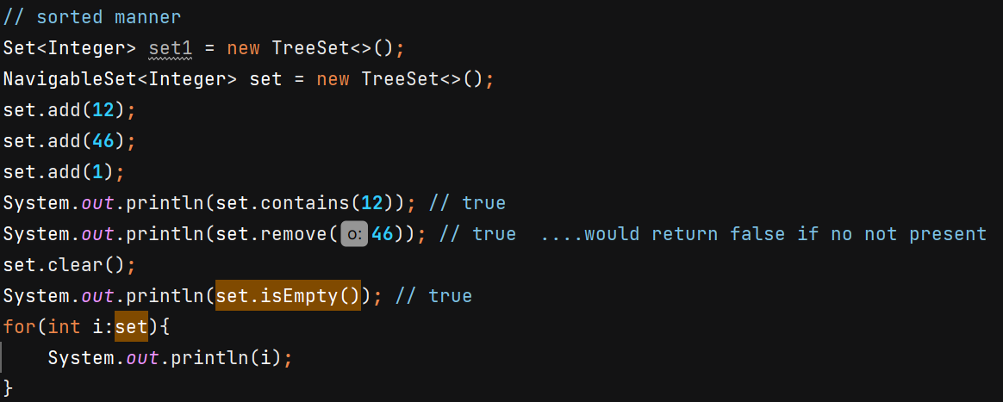

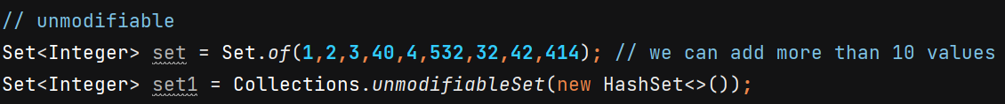

Collections.synchronizedSet() wraps the underlying set (e.g., HashSet) and synchronizes **every method** on the set using a **single lock**. This means that **every method call** (like add(), remove(), contains(), etc.) is synchronized using the same lock object. Even **read operations** (like contains() and size()) are locked. Although reads generally don’t modify the set, they still have to acquire the lock.

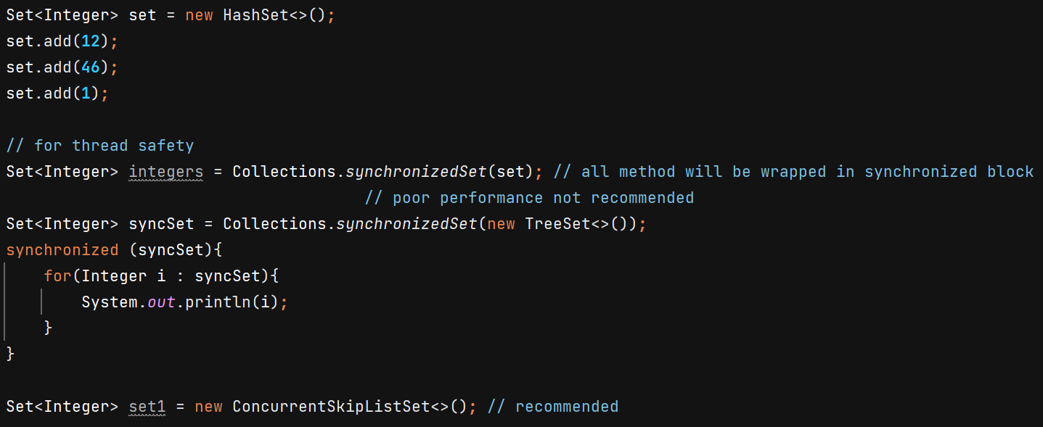

In ConcurrentSkipListSet, data is stored in sorted manner, useful in frequent reads & writes

CopyOnWriteArraySet –

* Thread safe
* Copy-On-Write mechanism
* No Sorted
* Iterators Do Not Reflect Modifications
* useful when read operations are frequent

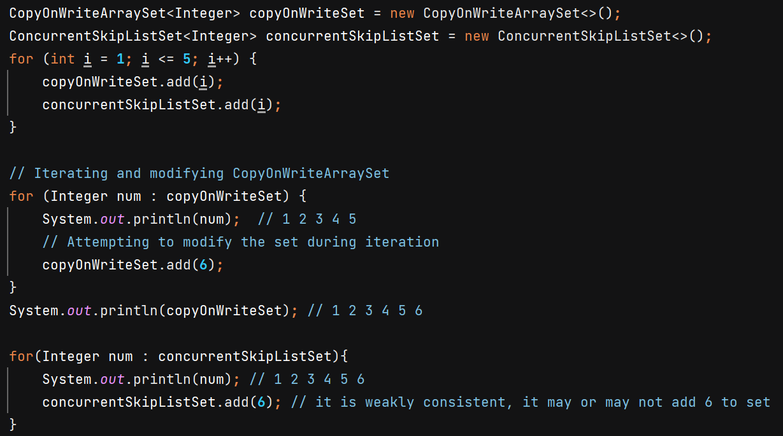

**Queues** – based on FIFO

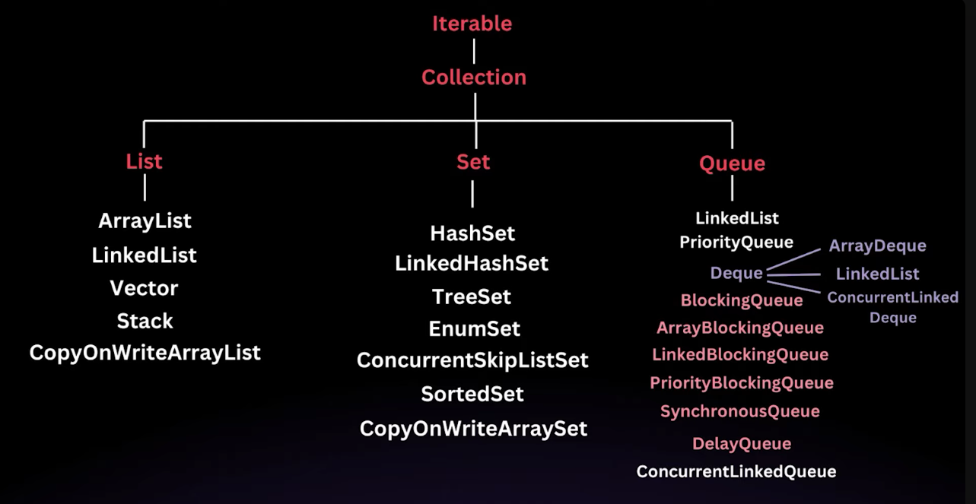

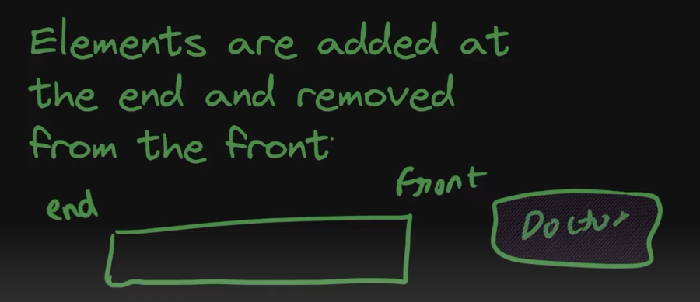

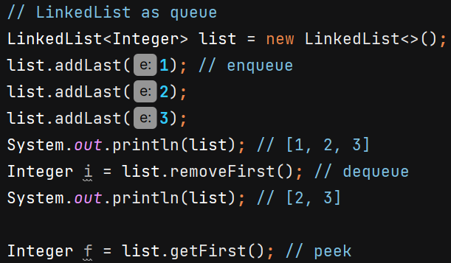

**Using Queue interface –**

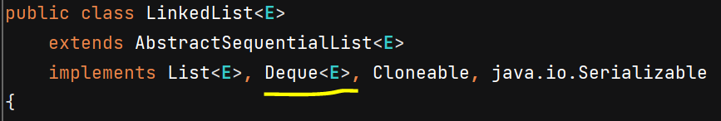

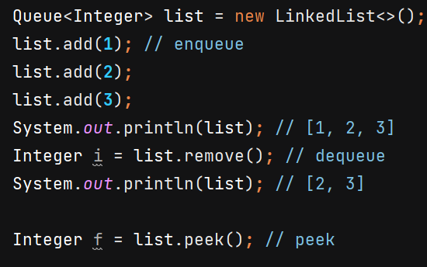

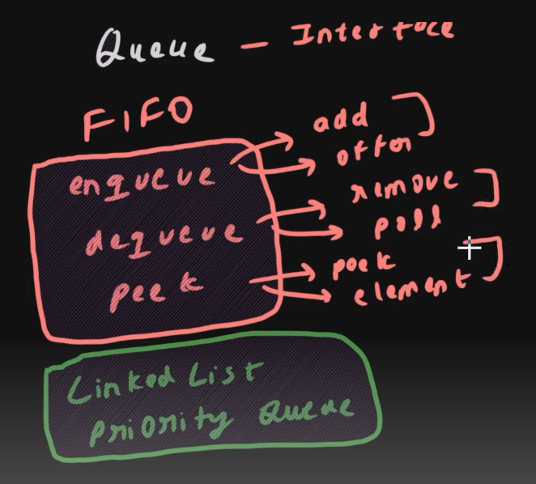

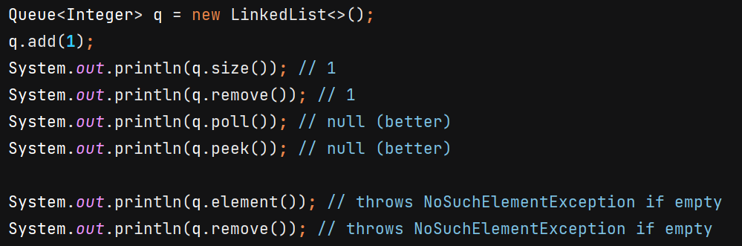

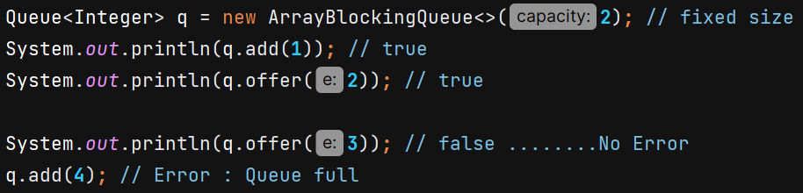

**Priority Queue –**

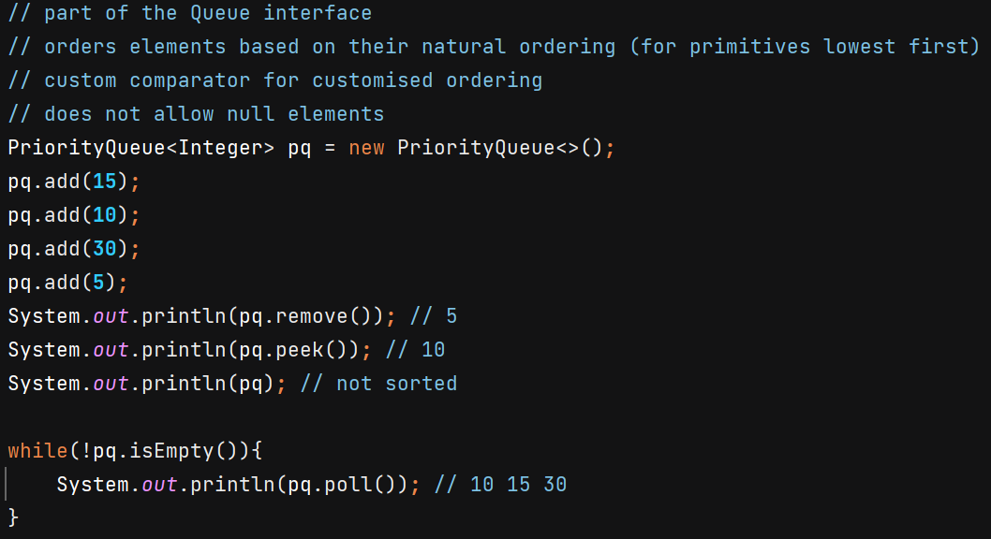

PriorityQueue is implemented as a min-heap by default (for natural ordering)

Min-heap 🡪 binary tree in which parent node is smaller than its child node, having smallest element on root

Time Complexity 🡪 O(1) in retrieve, O(logn) in insertion/deletion



**Deque –**

* double-ended queue
* allows insertion and removal of elements from both ends
* versatile than regular queues and stacks because they support all the operations of both

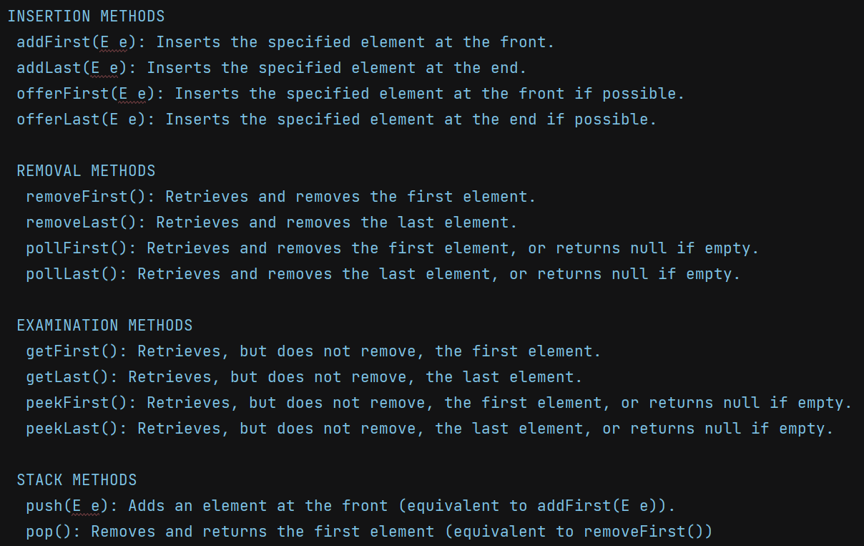

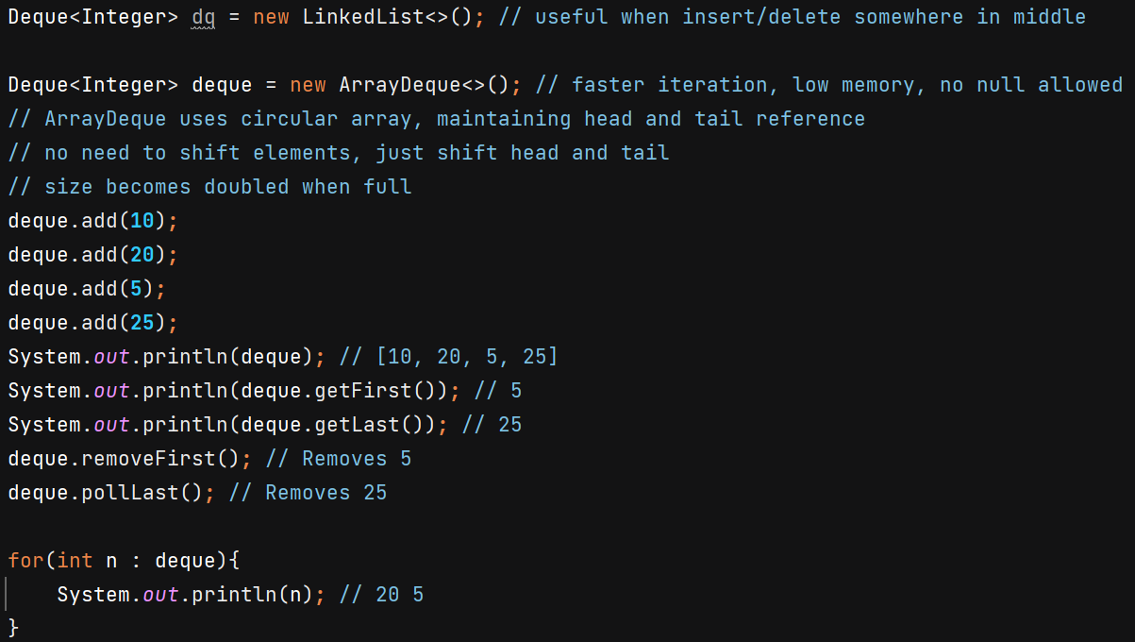

**Blocking Queue**

* Thread-safe queue
* Wait for queue to become non-empty / wait for space
* Simplify concurrency problems like producer-consumer
* standard queue ---> immediately  
   empty --> remove (no waiting)  
   full --> add ( no waiting )
* Blocking queue  
   put --> Blocks if the queue is full until space becomes available  
   take --> Blocks if the queue is empty until an element becomes available  
   offer --> Waits for space to become available, up to the specified timeout
* Needed when threads need to coordinate with each other

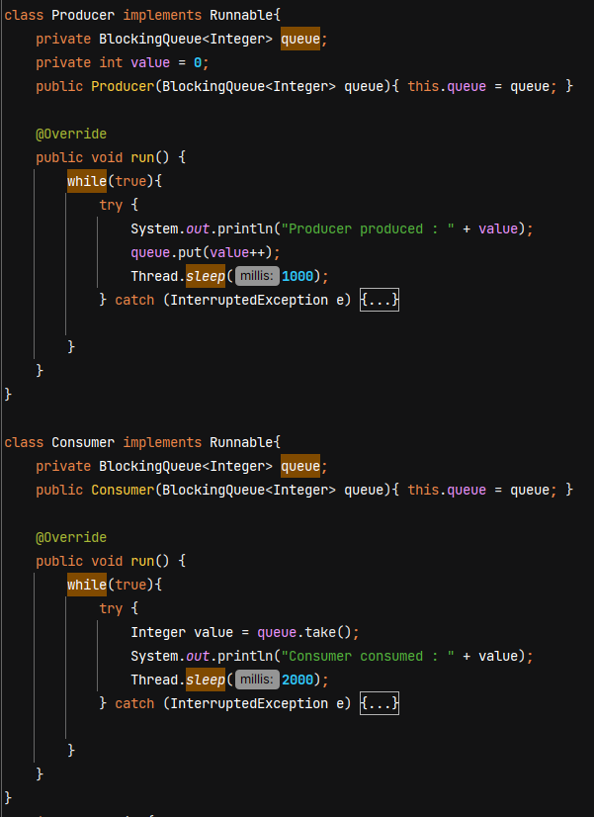

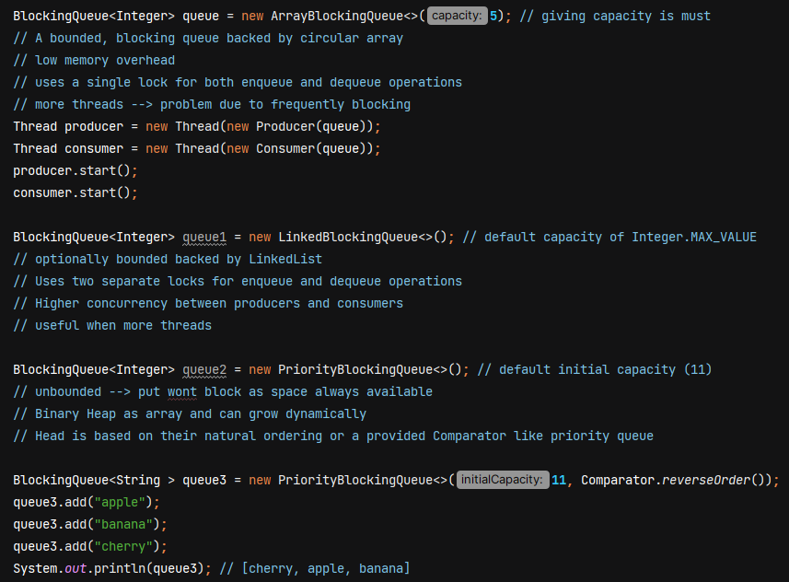

**SynchronousQueue -** each insert operation must wait for a corresponding remove operation by another thread and vice versa. It cannot store elements, capacity of at most one element

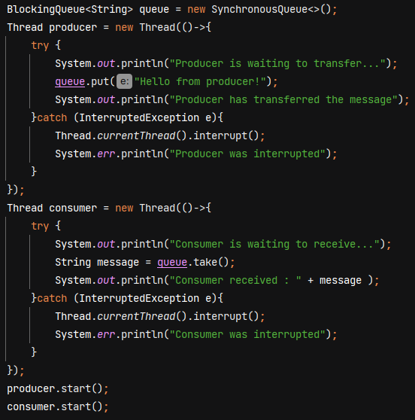

O/P - 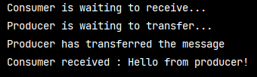

**DelayQueue –**

Thread-safe unbounded blocking queue  
Elements can only be taken from the queue when their delay has expired  
Useful for scheduling tasks to be executed after a certain delay  
internally priority queue

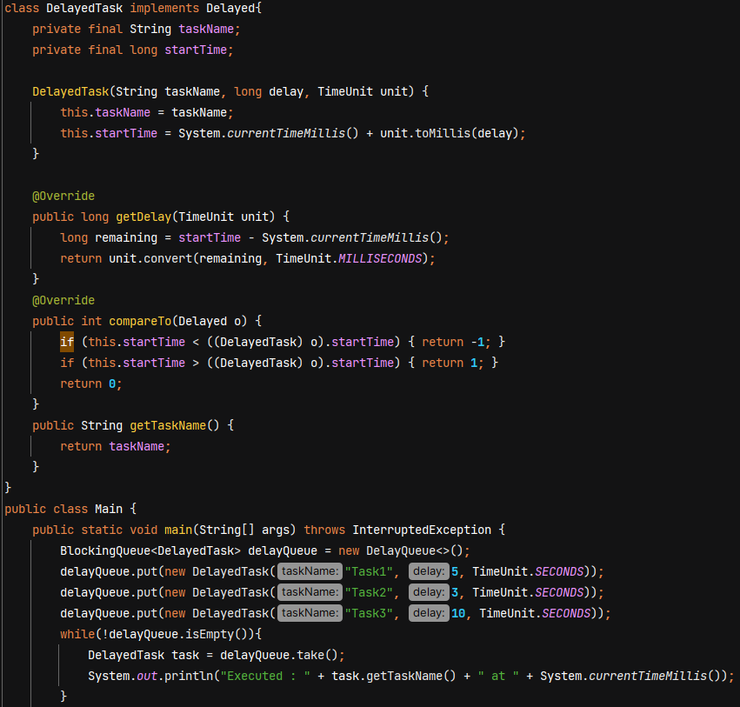

O/P –

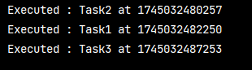

**ConcurrentLinkedQueue –**

Used when we don’t want to block threads but want to access queue. It supports lock free, thread safe operations.

Use compare & swap method internally like ConcurrentHashMap.

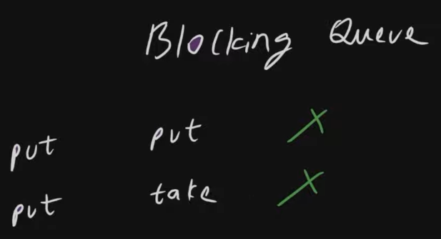 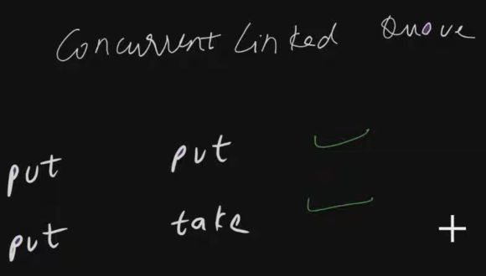

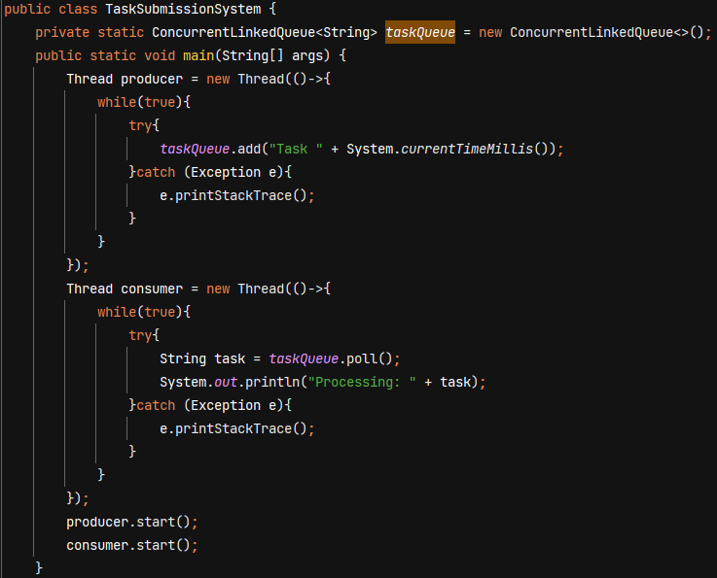

**ConcurrentLinkedDeque –**

